|  |
| --- |
| DSC_0077 |
| Major Development Project  Design & Technology |
| |  |  |  | | --- | --- | --- | | 25313399 |  | 2014 HSC | |

# Contents

[Cover Page 0](#_Toc396075384)

[Contents 1](#_Toc396075385)

[Background Information 3](#_Toc396075386)

[Project Proposal 3](#_Toc396075387)

[Identification and exploration of the need 3](#_Toc396075388)

[Design Proposal 5](#_Toc396075389)

[Preliminary Research 7](#_Toc396075390)

[Ecological 7](#_Toc396075391)

[Economical 8](#_Toc396075392)

[Social 9](#_Toc396075393)

[Ethical 9](#_Toc396075394)

[Legal 10](#_Toc396075395)

[Analysis of Research 11](#_Toc396075396)

[Justification of Need 12](#_Toc396075397)

[Rational Scenario 12](#_Toc396075398)

[Mimicking Scenario 12](#_Toc396075399)

[Regulation Scenario 12](#_Toc396075400)

[Standards Scenario 12](#_Toc396075401)

[MDP Parameters 12](#_Toc396075402)

[Time 13](#_Toc396075403)

[Skills 13](#_Toc396075404)

[Finance 14](#_Toc396075405)

[Design Brief 15](#_Toc396075406)

[Project management 15](#_Toc396075407)

[Areas of investigation 15](#_Toc396075408)

[Type of Research 15](#_Toc396075409)

[Conduction of research 15](#_Toc396075410)

[Level of information output 15](#_Toc396075411)

[Areas of Investigation 16](#_Toc396075412)

[Type of Investigation (see key) 16](#_Toc396075413)

[How I will conduct this investigation 16](#_Toc396075414)

[Justifications or reason for this investigation and direction for further action 16](#_Toc396075415)

[Criteria to evaluate success 17](#_Toc396075416)

[Criteria 17](#_Toc396075417)

[Priority 17](#_Toc396075418)

[Explanation 17](#_Toc396075419)

[Method of Evaluation 17](#_Toc396075420)

[Page No. 17](#_Toc396075421)

[Function 17](#_Toc396075422)

[Action, time and finance plans 19](#_Toc396075423)

[Action Plan 19](#_Toc396075424)

[Time Plan 20](#_Toc396075425)

[Finance Plan 22](#_Toc396075426)

[Item 22](#_Toc396075427)

[Item Description 22](#_Toc396075428)

[Proposed Cost 22](#_Toc396075429)

[Actual Cost 22](#_Toc396075430)

[Justification of Difference 22](#_Toc396075431)

[Selection and use of resources 26](#_Toc396075432)

[Project development and realisation 26](#_Toc396075433)

[Idea Generation 26](#_Toc396075434)

[Inner Workings 29](#_Toc396075435)

[Functions 35](#_Toc396075436)

[Aesthetics 35](#_Toc396075437)

[Circuit Creation 35](#_Toc396075438)

[Degree of Difference 39](#_Toc396075439)

[Exploration of Existing Ideas 40](#_Toc396075440)

[Consideration of Design Factors Relevant to the Major Design 40](#_Toc396075441)

[Appropriate Research and Experimentation of Materials, Tools, 41](#_Toc396075442)

[Industrial vs School Based Production 42](#_Toc396075443)

[Techniques and Testing of Design Solutions 45](#_Toc396075444)

[How I made the PCBs 45](#_Toc396075445)

[Radio Frequency Device to Use 49](#_Toc396075446)

[Ethernet Adapter Device to Use 55](#_Toc396075447)

[Project evaluation 58](#_Toc396075448)

[Criteria for evaluation 61](#_Toc396075449)

[Analysis of evaluation 61](#_Toc396075450)

[Impact of the major design project on the individual, society and the environment. 61](#_Toc396075451)

# Background Information

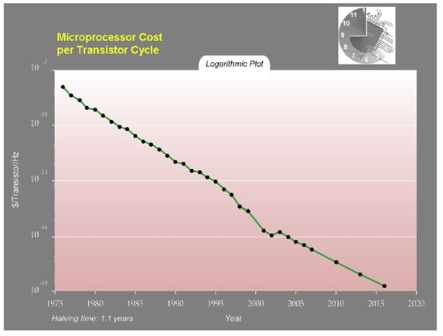Ever since the decline of price in complex fast microprocessors, the world of automation has been a popular hobby among electronic enthusiasts. With the introduction of the Internet, these automation hobbyists began to automate their own home by using a system of networks, inspired by the Internet. As of recent (2005) a huge increase in the popularity of home automation system has seen its way into the commercial market with houses been built using an automated appliances infrastructure. In 2008, Clipsal filed their first patent for the C-Bus technology, titled “Method for optimising return results of CBUS server and CBUS server”. This was the basis that C-Bus technology was built on and what made it stand out from similar products. Ever since I was young I have been intrigued by the inner workings of CBUS, and have drawn lots of inspiration. I plan on using this inspiration to complete my MDP.

# Project Proposal

## Identification and exploration of the need

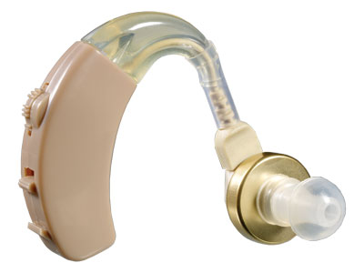As someone who frequently visits my grandmother’s house, I noticed a few things that operate differently and undesirably due to her increasing age and fragility. Some of her senses and functions that are being affected are often hearing and remembering memory functions, for example a door bell or a fire alarm audible alert not being heard, or forgetting to take medications. This is an inevitable outcome in the environment of most elderly people, especially with rates of hearing impairment at 5.7% for the population as a whole, with rates for the elderly at 30.4% as sourced from the Australian Bureau of Statistics.

Many times have I been at my grandmother’s house when an audible doorbell or medicine alarm has gone off and she has unwittingly completely ignored it. This greatly bothered me, and after discussing the possible consequences with my grandmother it too greatly bothered her. Consequently, I decided to setup a mini test to see how a different type of alert would help my grandmother overcome her loss and hearing impairment. The test was conducted informally where I told her that if the lights go very dim, full brightness, very dim, then back to full brightness there would be someone at the door, but if the light dimmed once and went back to normal brightness that it was time for her to take her medication. I visited her house randomly over the next 3 days, acting normally as she was possibly waiting for me to give this visual alert, but for the first 2 days I did nothing. It was on the third day that I tested our alert by signifying the doorbell using the light dimmer, and immediately my Grandmother smiled and opened the door.

Figure 1: A common solution to my grandmother’s problem – a hearing aid

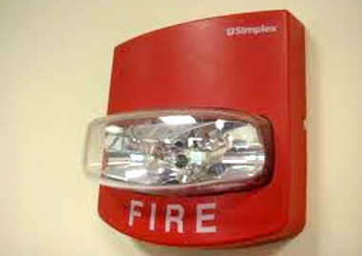Figure 2: A solution to the audible fire alarm problem – An existing, yet aesthetically displeasing solution

My Grandmother was very pleased with this idea of a visual alert over an audible alert and was happy to supply me with another idea for it, and that was to possibly have a visual alert for the fire alarm. I later setup various interviews with my grandparent’s friends who my grandmother thought had a hearing impairment. I asked them a few simple question to really see if there was a need for my product:

|  |  |  |  |  |
| --- | --- | --- | --- | --- |
| Question Number | Question | Reason for Question | Yes | No |
| 1 | Are you hearing impaired in any way? | To see if the participant is part of my target market | 10 | 0 |
| 2 | Do you ever find that you have missed someone at the door due to not hearing the doorbell? | To see to what extent their impairment is, and again, whether they are part of this target market. | 8 | 2 |
| 3 | Do you ever find you forget about your medication and/or not hear an alert for when to take them? | To see to what extent their impairment is, and again, whether they are part of this target market. | 9 | 1 |
| 4 | Would you be interested in a visual alert for these audible alerts you are missing? | To see if there is interest for my product in this market. | 8 | 2 |

5. “How much would you be willing to be prepared to pay?” Based on the qualitative answers I received, I concluded that a good price would be about $1000 for the entire solution.

6. “How would you like to see this visual alert?” to the 8 who answered yes to Q4. Out of 8 people, 4 gave answer that stimulated my thinking on product development direction:

“I would like to have my lights change colour. Say, green for the doorbell and red for the fire alarm. I just don’t want anything too flashy though due to my epilepsy”

“Hmm, I think if the light were to dim in a pattern when the doorbell rang that would be great. Even if they are off, if they could come on full then dim back down I think I could know if someone was at the door”

By combining these two ideas, I came up with a solution to the problem. If I could have red, green, blue and white lights that fade their brightness in a certain pattern, signifying an event, then this product could become a need for this market.

After evaluating the type of product that could solve this issue, I have come up with the identification of a lighting system that can take external events as commands to change the colour and brightness of a red, green, blue, and white light. With a solution that requires a system to be built, many more features are possible, so I decided to conduct another interview with the target market.

I politely apologised for bothering the interviewees again, but they seemed happy someone was developing such a product.

7. “As I am building a system that allows an external activity to change the brightness and colours of the lights, what activities would you like to see affect them?” Out of the 10 interviews I conducted, I received 3 answers that seemed like good ideas:

“I think it would be nice if we could have a way to turn these lights off using a remote, instead of having to get up to turn the light off. Lately I have struggled to do this as my muscles are starting to ache. I’m guessing this would be easy to include as it would be just like a doorbell but remote controlled and it would just trigger a different lighting event.”

“If the brightness is down, would that save me electricity? My bills have been too high lately and I am looking at ways of cutting it down.”

“Sometimes when I am reading the light colour is too ‘cold’ and bright. I have been looking at a warm coloured reading lamp for a while, but I don’t like reading in the same spot as a lamp is stationary. Could there be a button I could press to enter a ‘reading mode’?”

This interview proved to be of great assistance to me, and the qualitative answers to question 7 will really guide the direction of my product.

## Design Proposal

My design proposes to give the elder demographic a higher quality of life, by meeting a few crucial needs of the target market.

### Missing alerts due to being hearing impaired

Many elderly people struggle to hear audible alerts due to being hearing impaired. I propose to fix this issue by allowing a visual stimulus to be activated whenever an audible one normally would. This will not attempt to replace hearing aids, but instead is attempting to provide an easier all round solution that the elderly can rely on no matter what situation they are in.

### Struggling to turn off lights due to aching pains

Elderly people sometimes struggle with turning off lights, and it can become a huge chore that taxes their bodies every time with pain. I propose a simpler way for these lights to be controlled. This proposal is a secondary proposal that will be built off the primary proposal of missing alerts due to being hearing impaired, using the pre-built system I will need to make to meet that proposal.

### Concerned about high costing electricity bills each month

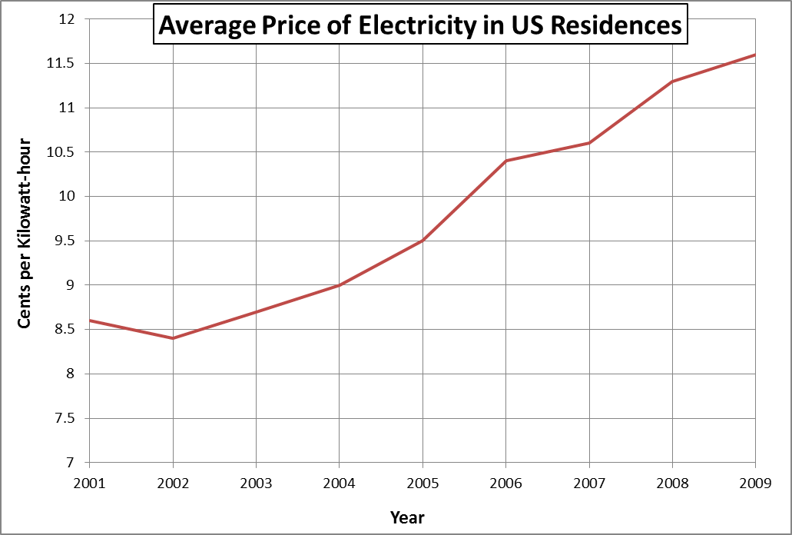

With the price of electricity rising much faster than inflation, people need to start taking more concern at their energy consumption. I propose a system that uses a lot less electricity by combining two features. The first feature is using low power consumption electronic parts, such as LEDs that can greatly reduce consumption by up to 50%. If I combine this with the second feature of lights that automatic turn off after a set time, I think I could reduce electricity used in lights by 25%.

### Light is too bright for comfort

A standard ceiling globe is not very customisable, and may provide discomfort for some. This is annoying as you are using your lights more than 3 hours a day and you want them to be the best they can. I propose a system that allows the customer to customer there lights brightness and colour to suit their own personal needs.

These four design proposals are crucial for me to meet if I want my product to be a success. The first proposal is my main need, and an entire automation system needs to be built to complete it. Because of this system being built for such a little proposal, I can easily branch out into three other secondary proposals that will allow the product to be of higher success while not taking away from the first proposal.

## Preliminary Research

I will completed preliminary research on all of the needs, to ensure they are real needs and not just charlatan needs. Missing alerts due to being hearing impaired: In 1993, the Australian Bureau of Statistics compiled the number of those with a disability, which was 18.1% of the population. Of this number, 31.5% had a hearing impairment. This equates to 5.7% of Australia’s population having a disability. This justifies the need for a visual stimulus rather than an auditory stimulus to be produced when an alert is activated. With the introduction of my product automating the visual light system in a house, many implication arise such as the ecological, economic, social, ethical, and legal factors which can implicate the design process. With the implicating factors, a designer must come up with a solution to go around the problem or fix the problem entirely. A designer has failed when the implication has no solution, and the uptake of the product will not be as great as it would be if the implication had a solution.

### Ecological

Ecology is relating to or concerned with the relation of living organisms to one another and to their physical surroundings. This fits in with home automation in terms of the pollution the product gives off, and the cradle to cradle life cycle of the product.

One of the main advantages of purchasing a home automation system is the aspect of saving the environment through the limiting of electricity usage. Home automation systems strive to achieve this goal by having timers behind most electrical appliances which automatically turn them off after a certain period of time, or a certain period of time when not in use. Another aspect of ecology in home automation is the cradle to cradle life cycle of the product. Most home automation products do not have any information on how their products are environmentally friendly in this respect, so it may be expected they are not the most recyclable.

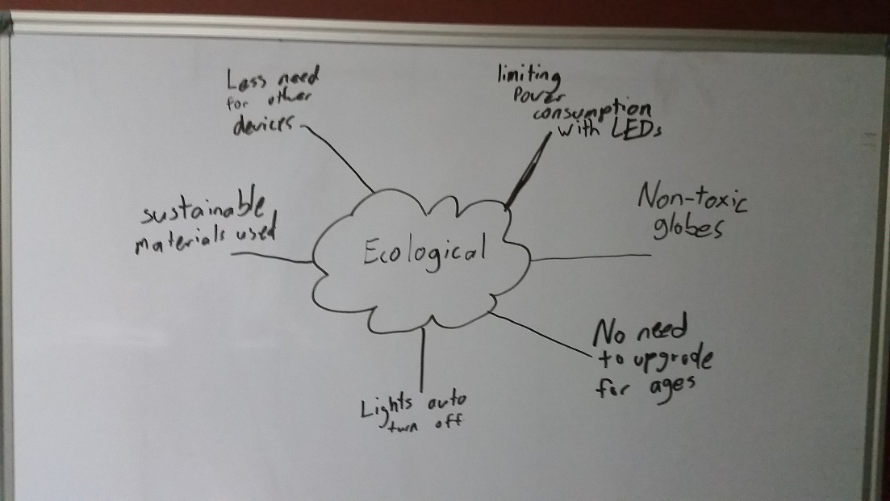

Through the use of these automatic timers that can turn off appliances, electricity can be saved. According to studies conducted by many parties, 41% of Australians keep lights on which are not in use <http://www.news.com.au/finance/money/complacent-australians-wasting-millions-of-dollars-on-energy-bills/story-fnagkbpv-1226766375012>.By saving electricity, we can reduce the amount of CO2 that is going into our atmosphere which is a leading contributor to global warming. Another positive behind the use of automation to turn unused lights off is reducing light pollution in communities where seeing the night sky is not possible. We should be wary about the materials used to build these products, as they do not provide profiles for how environmentally friendly these systems are, and it might not be environmentally friendly, even if lots of electricity is saved.

Implications that might arise from attempting to be environmentally friendly with such home automation systems is the process of installation. Although many users may think they are caring for the environment, they may make more pollution or waste through installation than what they will save with the product.

In total, if you are looking for a product that is good for the environment, this may be the product you are looking for, depending on various elements. Such elements can be the type of home automation you are installing and ensuring that the product has an environmentally friendly material profile, and when installation of the products occurring. It would be best for the environment if this system/product were to be setup during the building and wiring stage of the house. This ensures that there is no wasted materials as installation into a built house would require disposal of old parts and tear down of some walls.

### Economical

Economics in relation to home automation is the amount of money that will be spent, saved, or lost when purchasing or not purchasing a home automation system.

A common aspect of home automation is the consideration of the amount of money that can potentially be saved in electricity costs when automation is used to turn off appliances. A factor to consider when calculating the electricity saved by automatically turning off appliances is the electricity needed to run this automatic system. This is almost always accounted for though when the system is hooked up to two lights or more. Another factor is that although you will certainly save money in the electricity bill, it may cost more to purchase this product and install it. Alongside this, as technology is always advancing, will this product become obsolete in the near future, or will it adopt to a set of standards?

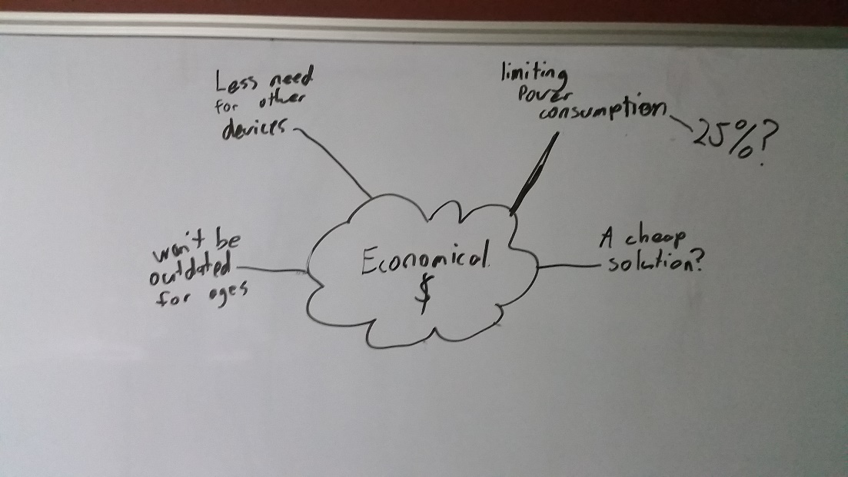

When calculating the savings made with a home automation system, it is not as simple as looking at your electricity bill and observing the lower number. It is a more complex formula that must involve the price of the product, the price of installation, time until obsolescence, and maintenance.

Implications may occur when using this product, so it is essential that upfront costs and maintenance are factored into the calculation of the economic benefit of the system. For instance, a family’s electricity bill may be reduced by $500 a year by using home automation. However, if the system costs $1000 to buy and install it will take 2 years for the system to pay for itself, and if the system costs money to maintain, the payback period would be even longer. In some cases the payback period may be too long to justify the system or the annual savings may not be enough to cover maintenance costs.

Before installing the system an objective cost benefit analysis should be carried out. A scenario that could save money would be where a family of 5 are planning on building a new, large home. They can install this product as they build the house, reducing the cost of installation. As the house is very large, many redundant lights may be accidentally kept on, costing the family lots of money in electricity. But because of the home automation system, these lights automatically turn off, saving the family from wasting money. A scenario in which home automation would not suit would be a small house that houses less than 3 people that has already been built.

### Social

Social means the interaction and relationship between living organisms. Social implications may arise when dealing with home automation systems, such as social status and trust issues when it comes to automated security.

Although not that expensive, home automation systems can be perceived as expensive toys for rich people. By installing a home automation system, people around yummy become jealous and start to think you are trying to reach a higher social status by throwing money away. Another social implication could be when one of your friends come over and you are trying to secretly enter your doors security code. Your friend may feel unsettled by this, and assure you do not trust him/her.

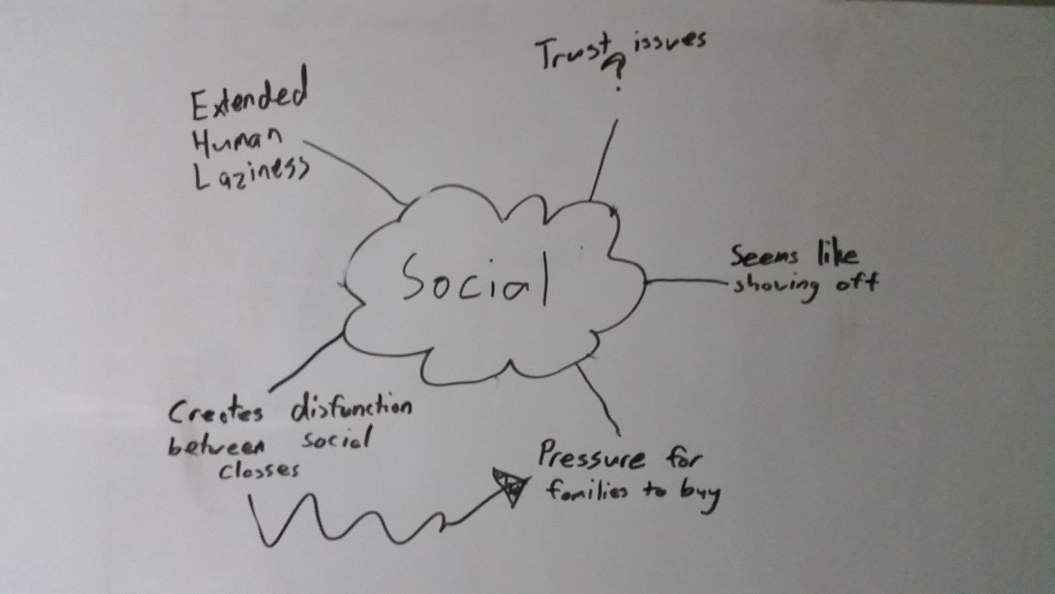

Unfortunately, the air surrounding home automation is that of a pretentious rich man, and installation may have negative connotations through social status with your friends. It's not until the product hits a more popular mainstream commercial setting that the social status behind home automation will lessen. The implication that arises through the use of home automation systems that take security measures, is that of trust. For example if Yehuda a keypad on your door that unlocked it, and you had a friend with you, do you try to hide your pin and potentially hurt your relationship or do you naturally enter your code in front of your friend, and thereby potentially threaten the security of your house.

Using the above information I think the benefit of having an automated house is above that of the issues previously raised, but as time goes on this will not be as much as a problem with uptake of this innovation. In regards to trusting your friends with the pin to your house, I think a design innovation could overcome this issue. Combining a key lock and a number lock together where you could use either to open the door would allow for a better system.

### Ethical

Ethical behaviour can be simply defined as not taking unfair advantage of someone or something. Such ethical implication that may arise from home automation are would electricity companies try to prevent this product from becoming publicly available, and the potential monitoring of your house by a company.

Because of the electricity that could potentially be saved, this innovation would be negative for electricity companies who are trying to sell you the electricity. These companies may buy the innovations rights and keep them for themselves to protect their profits. This is an unethical act to do that does not benefit anyone but the companies. Another ethical implication is the monitoring and or spying of home automation companies. For example, how would you feel if you were on holidays and got a call from the company saying tattoo had left your TV on? This is a major ethical implication that cannot easily be resolved.

The implication of an electricity company buying this technology is a major concern. Let's assume with home automation you could save 25% off of your electricity bill. This equates to exactly a 25% loss for the electricity company, which could ruin their business. In 2013 Energy Australia’s total revenue was $8,843,050,000<http://www.ibisworld.com.au/car/default.aspx?entid=11758>, if we take 25% of that number that equals roughly 2 billion dollars. Seeing these statistics, the innovator would make much more money by selling the innovation to Energy Australia, than selling it to the Australian public. The other ethical implication of concern is the use of these automation systems to unethically monitor and or spy on the users. A simple 'Band-Aid' solution to this problem would be to not have an overall monitoring system, and just let the user monitor it themselves. But this does not fully cover the implication as many users are too busy to monitor the system or may not have the understanding to monitor it themselves.

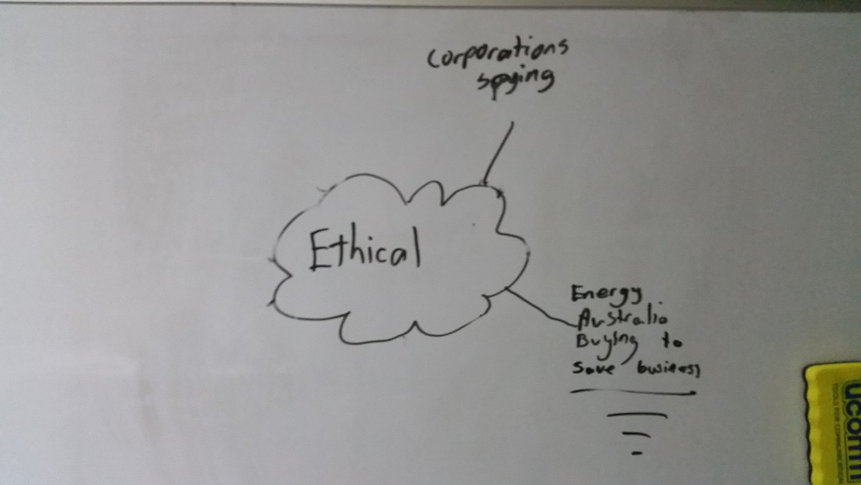

Concluding from the above information, an innovator would do much better selling the idea of the innovation to electricity companies rather than designing the product and selling it to the Australian public. But, another designer may design a similar product that is not breaching copyright law and could therefore still sell systems to the Australian public. With the idea of these automation system companies monitoring your house hold, it may only be wise to purchase the system if you have the required knowledge to monitor the system yourself instead of the company. This means they cannot spy on you, and your system is fully functional still. If you do not mind a company monitoring your household though, you may be fine with a limited understanding of this product and be able to use it to its full potential.

### Legal

Legal can simply be defined as the rules and regulations that govern how things should occur. As home automation is a relatively new innovation, there are still grey areas for what is legal and illegal. From these grey areas, implications can arise, such as the level of access companies have with these automation systems, and potential monopolies on the installation and maintenance of the system.

Legal implications arise due to the grey area of the current laws surrounding home automation. Do companies have full access to these systems, opening a way for them to collect data about you, or is there a law in place to stop this? Well, due to it being a grey area, there isn't a clear answer, possibly allowing company’s unlimited access to your automation system. Another implication may be the installation of such a system. Although the process may be easy for some, you will probably need to get the relevant licensed tradesperson to install it and certify its safety.

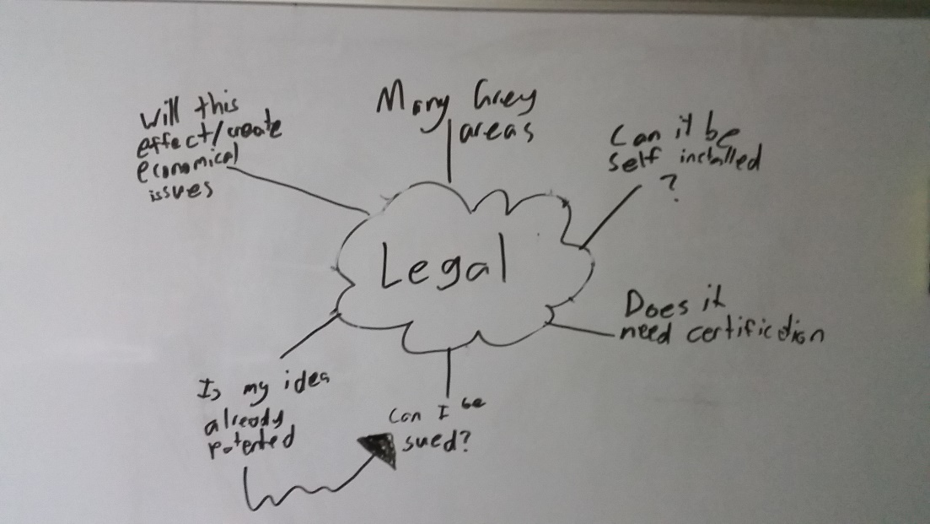

As home automation picks up in popularity, so will the amount of laws created to protect the user of such systems. It may be safe to wait until the law on home automation is black and white, rather than a grey area before installing. One of my main concerns is the implication of installation. With current households, most things more than replacing a light bulb require a certified tradesmen to do it for you. The home automation company may try to get a special license that is required to be able to install such a system, limiting the amount of tradesmen that can complete the installation to very few. The company could also make the tradesmen charge a very high installation fee, in attempts to get more money out of the customer.

Due to this grey area of laws, it might be best to wait until a better system of laws regarding this innovation is put into place. If you are not concerned though with companies collecting your data or potentially spying on you, there is no need to wait, as these are the only legal implications which are in the grey area. To the second implication, it would be best to check with the company about installation procedures before purchasing. If the company says they you need a special type of tradesmen, check first how much this would cost. If it's obvious they are over charging, look at a different company’s product.

## Analysis of Research

Through the use of citing reliable sources, my preliminary research has shown me what I can expect when designing this product. With the research comes some negative points in regards to what I would like to do, especially implicated in my legal research. Although, there are still many positives that I can hope to achieve such as the ecological and economic benefits that I explored.

|  |  |
| --- | --- |
| Factor | Key Point |
| Ecological | * Reduction of electricity consumption which is good for the environment |
| Economical | * Reduction of electricity bill due to automation |
| Social | * Controversial view of owner an automation system due to possible “showing off” |
| Ethical | * Companies collecting data on users through an automation system |
| Legal | * The laws are not clear what is legal and illegal, which will slow down the design process |

## Justification of Need

After establishing that there is indeed a market for this product, I have to evaluate my findings and ask myself why I am doing this product. A good criteria to evaluate the justification of a need is to have a rational scenario, mimicking scenario, regulations scenario, and a standards scenario.

### Rational Scenario

This is the action of looking at hard facts and numbers to see if they need can be justified through logic. Rational scenarios do not take into account ethics or legalities, but nor does it exclude them. It is simply the logic behind the need. In my case, the logic is sound and is justified by my statistic in my preliminary research. The data shows that there is definitely a target market for my product and on

### Mimicking Scenario

This is more colloquially known as the “if they did it, we can do it” scenario. The mimicking scenario is the research of other products on the market and looking at how they became a success, and drawing inspiration from that. In my research I have thoroughly gone through the design process and marketing process of the Domus - RGB LED Down light Flare. From this product I have drawn inspiration from such features as the aesthetic ‘satin white aluminium frame’ and the functional wireless communication method. Although the mimicking scenario is a good method to success, if you mimic a product too much, your own product might look like knockoff or not become successful as the exact same product is already out there on the market.

### Regulation Scenario

In this scenario you look closely at the rules and regulations in place that you must work with to create your product. An initial need I had in mind was for an easy installation of my product by the user. This would allow the average human to buy my product off the shelf and install it themselves with ease when they get home. Unfortunately, due to regulations and laws this need could not be fulfilled by my product, and thus will shape the design process of my product as it will no longer target that particular aspect.

### Standards Scenario

While regulations provide an explicit measure to justify change, standards expectations provide implicit reasons for change. When you use the standards scenario to justify your agenda, you are not proposing that the product needs something as much as you are suggesting that if the product doesn’t need that something, it will be of a disadvantage. Through this scenario, I can justify the use of the mobile phone as a controller for my product as not having it used in this product, in today’s era of technology, will be of a great disadvantage.

## MDP Parameters

When creating my MDP there will be many parameters I must abide to. Many of these parameters would not be as strict if this project was created professionally, but since I am a Year 12 student the parameters are very closed in. Some parameters to consider are time, skills, finance, resources, and personal limitations.

### Time

Time is a major consideration when designing the product as you cannot go over the deadline, nor do you want to finish with too much time spare. Finishing over the deadline will result in a penalty to the success of the product. In this case the penalty is major and result in a complete failure of the product. If I finish with too much time to spare, than my product may not be the best it can possibly be.  
In total, I have about 200 days to complete this product.

### Skills

This parameter can be split into 2 different categories pre-learned skills, and intra-learned skills.

#### Pre-learned Skills

Pre-learned skills are skills that I already have acquired.

|  |  |
| --- | --- |
| 1 | ***Fundamental Awareness*** |
| (basic knowledge) |
| 2 | ***Novice*** |
| (limited experience) |
| 3 | ***Intermediate*** |
| (practical application) |
| 4 | ***Advanced*** |
| (applied theory) |
| 5 | ***Expert*** |
| (recognized authority) |

|  |  |  |  |  |
| --- | --- | --- | --- | --- |
| Skill | Proficiency Level | Where I learnt it | Where I am possibly going to use it | Needed proficiency Level |
| Soldering | Advanced | Self-taught at home through a hobby for repairing old circuits. | I will be using this skill throughout my project to solder components together | Intermediate |
| Programming C | Fundamental Awareness | Reading other peoples code | To program the behaviour of integrated circuits such as the common ‘Arduino’ chip the Atmega328PU | Intermediate |
| Programming Python | Intermediate | Self-taught through the Board of Studies Software Design and development course | To program the main control system that will dispense commands to the light systems | Advanced |
| Circuit Building | Novice | Through YouTube tutorials | To build the senders and receivers of the lights | Intermediate |
| Network Infrastructures | Advanced | Year 10 work experience, and ongoing applied theory for my own homes infrastructure | To allow the user to interface with the lights | Novice |

#### Intra-learned skills

Intra-learned skills are skills that need to be learnt in order to complete a stage of development in either the planning process or design process. For this project I will need to learn many skills to a high proficiency level. As I don’t quite know what my final product will be, the learning process of these skills will be documented later in this portfolio. I also need to be careful of my mental parameter and not take on a workload that is too great to be completed in the set amount of time.

### Finance

This parameter can be split up into 4 different sub parameters, research and production cost, cost of the final product, resources, and personal limitations.

#### Research and Production Cost

This is the total budget for the purchasing of different materials and resources to create my product. Usually when creating a product this is a very expensive process and cannot usually be done without a money incentive kick-start. As I am only in Year 12 with no income, I do not have much money to spend on various resources and materials for the design, so I am planning on setting up a spreadsheet that documents all of my purchases. My mum and dad have both granted me $200 to spend freely on this product, so this will be my maximum budget. Thankfully many resources I would normally have to pay for are free to me through my schools own workshop rooms which offer lots of equipment, I also have the resource of being able to talk to knowledgeable individuals in the field through that Technology Staff at my school. With these 2 free resources, I think $200 should be enough to complete the research and production of a few of my products.

#### Cost of the Final Product

Through my preliminary research there are many competing products that do similar things to mine. I have not done in-depth research on these products but a main flag stood out to me on each, their price. Most of these products are averaging roughly $100 per bulb! And that’s even without the main computer system, which either does not exist or goes upwards of $1000. This is ridiculous and is one of the main aspect keeping these types of products from reaching mainstream. I propose my final product to cost around $25 per light, and $100 for the computer system.

#### Resources

At home I have very little resources I can use, besides a soldering iron. Thankfully, I have access to the schools equipment that I can use almost every day for no cost.

#### Personal Limitations

I need to be aware of my financial limitations and that the money I have is not infinite. I should create a finance plan to calculate how much this project will cost me, updating it and evaluating it every time something is purchased and every time I am thinking of purchasing an item. Fortunately, although I myself do not have a lot of money, my parents are willing to grant me $200. This is not a number set in stone, and I am sure if I need another $50 I could politely ask my parents and it may be granted. This gives me a very fortunate situation where a financial mistake will not cost me the entire project.

## Design Brief

|  |  |
| --- | --- |
| **Need Analysis** | |
| What type of need has been identified? | Something that is going to give a visual alert for those who cannot heard audible alerts. |
| Who is my target market? | My current target market is those with hearing impairments. |
| What do they want my product to do? | They want my product to be a cheap solution to allow them to visually see alerts that would normally be only audibly noticed. |
| How do existing products fall short of providing for this need? | Existing product have fallen short of this need such as hearing aids which do not cater for the entire market and are often not worn when the need is present. |
| What demographic features identify this group? | The main demographic is the elderly who have hearing impairments, but this could extend to anyone who has a hearing impairment or even someone who prefers a visual alert over an audible one. |
| What could I do to expand my target market? | I could expand my target market but adding extra features onto this visual alert system. A line must be drawn though, as successful products do not attempt to fill too many target market’s needs. |
| Can I produce a product which is both desirable to the target market and economically viable? | Yes, this is a main factor that I am trying to meet with my product. It should be economically viable through the use of high quality yet low cost materials. |

# Project management

## Areas of investigation

|  |  |  |  |
| --- | --- | --- | --- |
|  | Type of Research | Conduction of research | Level of information output |
| 1 | Descriptive | * Focus Groups * Interviews | High |
| 2 | Historical | * Investigation of historical events | Medium |
| 3 | Experimental | * Developing Prototypes * Sample Testing | Very High |
| 4 | Operational | * Assessing pre-existing products * Testing of pre-existing products * Visiting Sites * Product Testing | Medium |

|  |  |  |  |  |
| --- | --- | --- | --- | --- |
|  | Areas of Investigation | Type of Investigation (see key) | How I will conduct this investigation | Justifications or reason for this investigation and direction for further action |
| Electricity use of an LED | * Electricity usage of an LED * Electricity usage of a standard globe | Experimental | I will set up two circuits that consist just of a power supply and the light source in question. I will measure the voltage and ampere that the light uses, and convert it to watts to test what uses the most electricity | I am investigating this to make sure that LEDs can be used as a synonymous substitute to traditional ceiling globes. If LEDs use around the same electricity or less electricity than traditional standard globes, I will continue my project using LEDs. |
| Brightness of an LED | * Luminosity of LED * Luminosity preferred by public | Experimental | I have purchased a light sensor from Jaycar that gives a reading of the brightness received, varying from 0 for no brightness to 1024 for maximum brightness | I am investigating this to make sure that LEDs can be used as a synonymous substitute to traditional ceiling globes. If the LEDs are brighter than or just as bright as traditional ceiling globes, I will continue to use LEDs for my project. |
| Cheapness and quality of variable wireless communication methods | * Range the communication method can send data * Cost the communication method costs * Accuracy of the data sent and recieved | Operational | I will conduct this investigation by exploring the different aspects of each method such as the price, sending range, accuracy of the data, speed the data is sent at. This will be documented later in my folio. | I am investigating this to ensure that the method I use to send data is accurate and can be sent at a long range of 30m for a cheap price. When I investigate each communication method, I will pick the method that gave the best results and will use it in my product |
|  |  |  |  |  |
|  |  |  |  |  |
|  |  |  |  |  |
|  |  |  |  |  |

## Criteria to evaluate success

|  |  |  |  |  |
| --- | --- | --- | --- | --- |
| Criteria | Priority | Explanation | Method of Evaluation | Page No. |
| Function | | | | |
| Easy implementation / install | High | In order to be successful, the  product needs to be easy to implement. This includes how easy it is to install, and connect it to the various sensors. | Timed tests of the time it takes to install a normal light, and the light++. It should not take more than twice as long to install the light++ then the normal light. |  |
| Consumer Use | High | To be considered a success this product must get a positive response from the target market. | I will conduct a demonstration in front of the target market (the elderly) and record their opinions through a survey. |  |
| All in one solution | High | To be a success the product must be able to work without any use of additional competing products. | Through an evaluation of an electrician when the product is replacing the existing system. |  |
| Intuitive | High | The product must be able to function correctly when used by a beginner with no previous knowledge. | The target market (elderly) will be given a test of the product and a survey will record whether or not they could use it. |  |
| Improves on existing competing product | Medium | Must contain all features out there that similar products use, plus more additional features. | <to fill> |  |
| Aesthetics | | | | |
| Shape and Form | Low | Although not a high priority, the aesthetics of the product can greatly influence a customer’s thought on the function of the product. |  |  |
| Luminosity | High | For the product to be a success it must be able to replicate the light intensity of the standard ceiling globe. | I have purchased a light sensor which I will use to measure my own homes ceiling globes. I will record this data then compare it with data I have collected from using this testing method on <> my product. |  |
| Colour of Light | High | To be a success the product must be able to replicate many different light colours. Some LEDs cannot do this, so I need to be sure to find the right LEDs |  |  |

## Action, time and finance plans

### Action Plan



### Time Plan

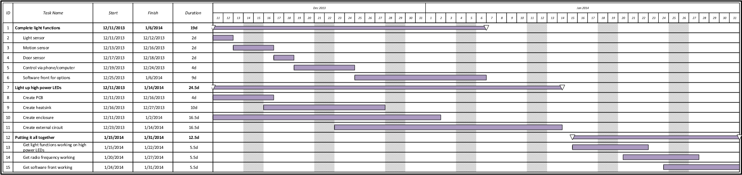

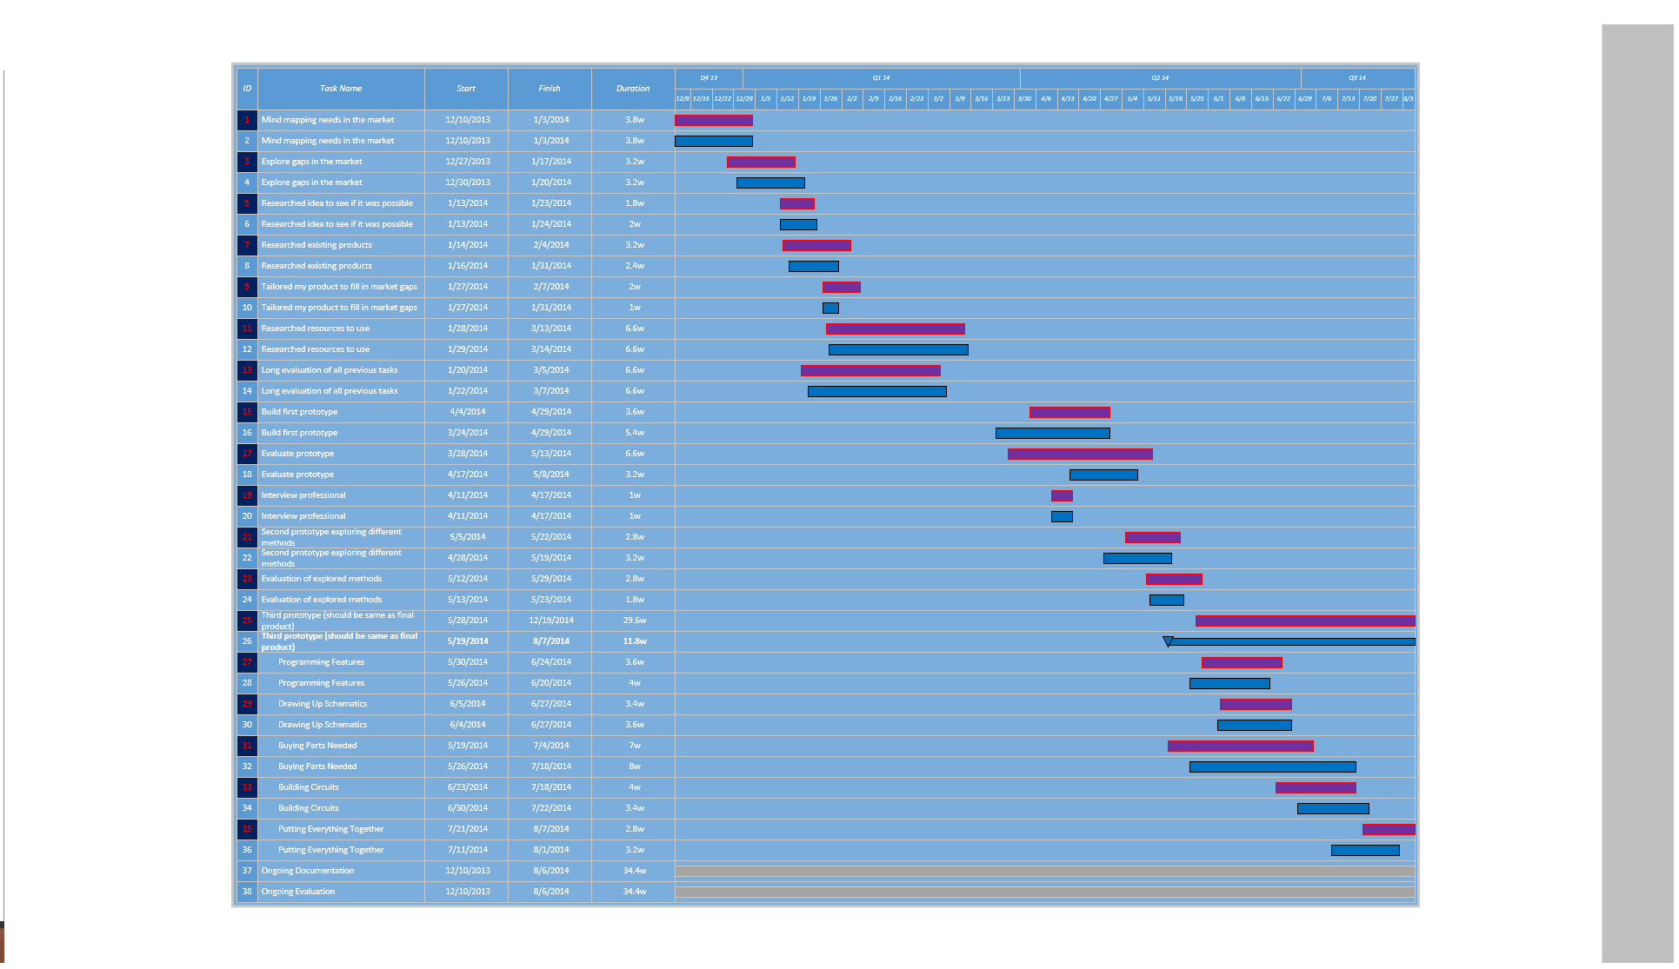

### Finance Plan

My budget for this project is $200 as previously mentioned, as my parents have kindly contributed this to me. This budget is not set in stone though, as I can always take money from my own bank account. It is still very important I strictly stick to the structure of this finance plan.

|  |  |  |  |  |
| --- | --- | --- | --- | --- |
| Item | Item Description | Proposed Cost | Actual Cost | Justification of Difference |
| Raspberry Pi | The raspberry pi is the brains of the entire project. It is the centre of all communication that occurs in Light ++’s infrastrcutre. | 50 | 45 | I applied for an education coupon to receive $15 off the Raspberry Pi and was granted it. The raspberry pi was $60. |
| 3 x Arduino Uno | The Arduino Uno’s were initially to prototype each node (light). Since then <> they have changed purpose and now can be considered as part of the final product. Arduino Uno’s contain a microprocessor that I have hooked up to the LEDs. The microprocessor sends out a singal to these LEDs based upon certain events that are happening around them. | 60 | 25 | I purchased the first one for $15, then purchased the second one for $10 as second hand. The third I borrowed off a friend for free. |
| 6 x NRF240I+ | The NRF240I+ radio frequency modules are very reliable for sending small amounts of data over radio frequency waves. They are at every point of Light ++’s infrastructure, including hooked up to the Raspberry Pi (through median of an Arduino), and also connected to each Light ++ node. | 20 | 24 | Initially I purchased 2 of these from eBay for $2 each, they worked fine but took 4 weeks to arrive. The next 4 I wanted fast, so I decided to order from an Australian warehouse called dx.com. They were $5 each and were exactly the same as the eBay ones. |
| 25 x RGB LEDs | These are just simple RGB LEDs with a diameter of 5mm. Their brightness is not good enough to be in the final product, but I am purchasing them for prototyping. | 5 | 4 |  |
| 25 x White LEDs | These again are just simple LEDs that emit a white colour. They are not bright enough for the final product, so instead will only be used for prototypes. | 2 | 2 |  |
| Various Resistors | Throughout my project I will need various resistors, varying from 1 Ohm though to 15k Ohm. Although not all variations of ohm rsistance will be used in the final product/prototypes, I will need them on the go for building test circuits or debugging various compnentns. | 20 | 2 | One of my dad’s friends had lots spare that he did not plan or know how to use, so he kindly gave them to me. |
| 3 x Bread Boards | Bread boards, or also known as prototype boards, are just simply a large board with female pin headers. This allows me to easily just plug a component into the board without having to solder anything. | 15 | 7 | I purchased my first one for $7, borrowed the second one from the same friend whom I borrowed the third Arduino from, and I got the 3rd breadboard free through a deal on a website while buying unrelated electronic components. |
| Other Competitors Products | I will need to purchase other competitors products to see how they have achieved a task. This will allow me to get more of an indepth analysis on how others have attempted to comply with a need. | 30 | 0 | My Design and Technology teacher had 2 spare that I could keep. |
| 1 x HanRun W5100 Wiznet Ethernet Shield | This is an addition to the Arduino Uno that allows it to receive HTTP requests through a local IP address. I was initially planning on using this instead of the Raspberry Pi, but the Arduino itself did not have enough processing power, so I had to opt for the Raspberry Pi which already had a built in Ethernet controller, making the Wiznet Shield redundant. | 15 | 10 | Was cheaper than I expected |
| 1 x SPI Ethernet Hookup | Again, the same as above. This was initially purchased as a add-on to the Arduino, but this idea was later discarded. I purchased two different Ethernet controllers to test which one was best. | 10 | 4 | Was cheaper than I expected |
| 2 x High Power LED Star |  | 10 | 10 |  |
| 5 x Perf Boards |  | 15 | 10 | Was cheaper than I expected |
| 1 x Sheet of PCB copper |  | 20 | 20 |  |
| 1 x Acid Powder |  | 20 | 0 | My Design and Technology teacher has some spare that I could use. |
| Other Various Components |  | 30 | <> |  |
|  |  | <> | <> | 5 |
|  |  |  |  |  |

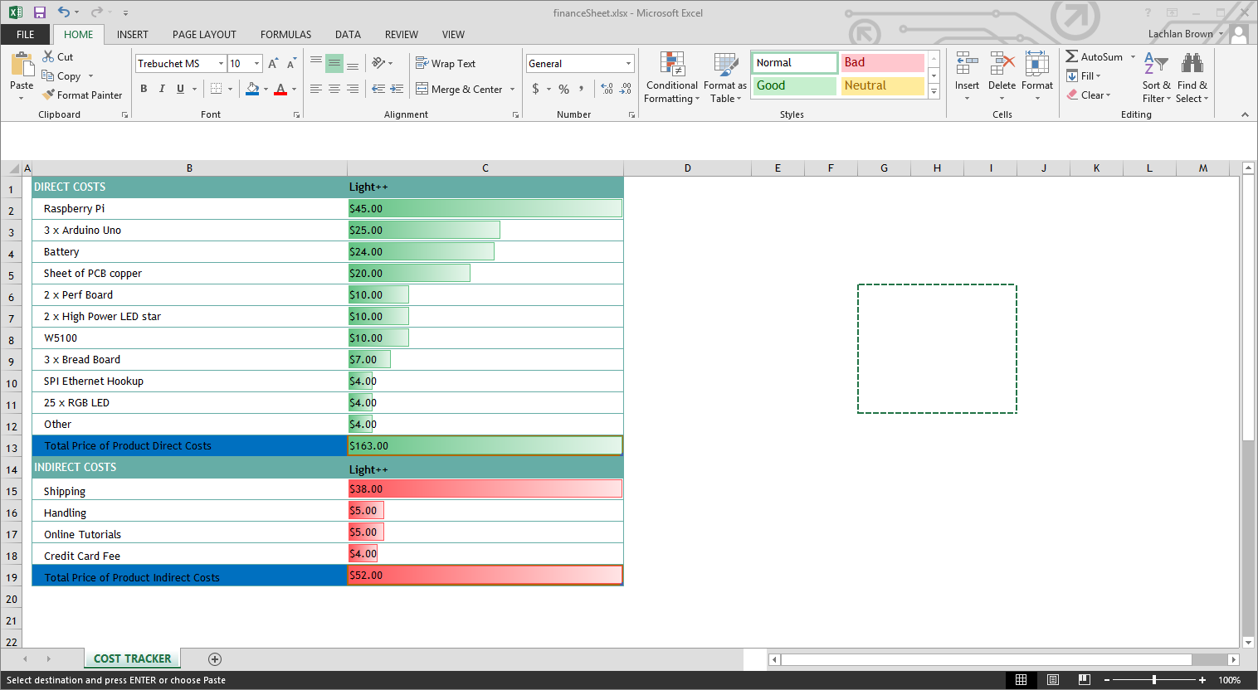

## Selection and use of resources

### Radio Frequency Device to Use

I had the choice of 2 different RF transceivers, the 433Mhz RF transmitter and receiver (which will be referred to as 433), and the Nrf24L01 transceiver (which will be referred to as Nrf) for the wireless communication method. The 433 consists of 1 transceiver and one receiver, whereas the Nrf consists of just one transceiver, where 2 is required for communication. To find out which one would best suit my product, I ran a few tests on each device:

#### Range Minimum Test

##### Aim

To test what the minimum distance is that the two different RF devices can communicate with data accuracy over 90%. This will allow me to know where to install the communication modules when installing the system.

##### Equipment

* 2 x Arduino Uno w/ Power Supplies
* 1 x LCD screen
* 1 x LED
* 1 x 433
* 2 x Nrf
* 1 x Push Button
* Various Wires
* Tape Measurer

##### Procedure

1. Write code for communicating test packets of data, and displaying accuracy on the LCD screen of the receiving Arduino. Pressing the push button will send 1 data packet from the sender to the reciever.
2. Set up the two Arduino’s at a set distance apart using the tape measure (I used 10m because of prior knowledge)
3. Press the push button
4. If the LCD is showing the accuracy is greater than 90%, half the current distance and go back to step 2. If the accuracy is less than 90% move the arduino’s back half the distance they were moved towards each other before.
5. After repeating steps 2, 3, 4 a definite distance will be found where the RF devices cannot communicate with a 90%+ accuracy
6. For a last check that the distance is right, a 10% check is used, where the arduino’s are setup 10% close than the perfect distance and tested. The accuracy should be below 90%. Then the arduino’s are setup 10% back from the perfect distance. The accuracy should be greater than 90%, or even equal. If these two conditions are not met, step 2, 3, 4 should be repeated more.

An example of this procedure with the 433 looked like:

* 433’s at 10m gave 95% accuracy
* Moved forward to 5m distance
* 433’s at 5m gave 94% accuracy
* Moved forward to 2.5m distance
* 433’s at 2.5m gave 94% accuracy
* Moved forward to 1.25m distance
* 433’s at 1.25m distance gave 88% accuracy
* Moved back to 2m distance
* 433’s at 2m distance gave 92% accuracy
* Moved forward to 1.5m distance
* 433’s at 1.5m distance gave 90% accuracy
* Moved back to 1.6m distance
* 433’s at 1.6m distance gave 91% accuracy
* Moved forward to 1.4m distance
* 433’s at 1.4m distance gave 89% accuracy

##### Safety

Going in to this experiment, I did not have many safety concerns other than the radiation RF transmitters give off. I combatted this safety concern by making sure I never had my head too close to the transmitter while it was on and sending data.

After going through the procedure, I accidentally cut myself on the tape measurer while winding it back up. This was careless of me, and through evaluation I have decided that it would be a good idea to take more care around the tape measurer and wear gloves when winding the tape back in from a distance greater than 5m.

##### Discussion

The procedure requires a bit of common sense to come to a conclusion where a definite answer is given, this is poor design if this procedure was made public. Another flaw in this experiment is the fact that one of the modules may have been broken and not working to its full potential. I combatted this by doing multiple test, each time using different hardware modules. A better way I could of done this test was to have multiple receivers that found the average between them, instead of relying on a single receiver.

##### Conclusion

I concluded that the 433’s minimum sending distance with an accuracy greater than 90% is 1.5m. This is a very large distance when compared to the conclusion of the Nrf’s minimum distance of 5cm. Although comparatively, the Nrf was much better than the 433, anything less than a minimum of 3m is needed for this product to be successful when installed correctly. So in all, the Nrf wins as it allows for human error when installing the modules if two modules are too close.

#### Range Maximum Test

##### Aim

To test what the maximum distance is that the two different RF devices can communicate with data accuracy over 90%. This will allow me to know what the maximum coverage distance is for each RF module and allow me to install the system to its fullest potential.

##### Equipment

* 2 x Arduino Uno w/ Power Supplies
* 1 x LCD screen
* 1 x 433
* 2 x Nrf
* 1 x Push Button
* Various Wires
* Tape Measurer

##### Procedure

1. Write code for communicating test packets of data, and displaying accuracy on the LCD screen of the receiving Arduino. Pressing the push button will send 1 data packet from the sender to the reciever.
2. Set up the two Arduino’s at a set distance apart using the tape measure (I used 15m because of prior knowledge)
3. Press the push button
4. If the LCD is showing the accuracy is greater than 90%, move the arudino’s back 5m. This step should be repeated until the accuracy is less than 90%.
5. By finding where the accuracy is 90%, a 10% distance check should be used. The arduino’s are setup 10% close than the perfect distance and tested. The accuracy should be above 90%. Then the arduino’s are setup 10% back from the perfect distance. The accuracy should be less than 90%. If these two conditions are not met, step 4 should be repeated more.

##### Safety

Going in to this experiment, I did not have many safety concerns other than the radiation RF transmitters give off. I combatted this safety concern by making sure I never had my head too close to the transmitter while it was on and sending data.

After going through the procedure, I accidentally cut myself on the tape measurer while winding it back up. This was careless of me, and through evaluation I have decided that it would be a good idea to take more care around the tape measurer and wear gloves when winding the tape back in from a distance greater than 5m.

##### Discussion

The procedure requires a bit of common sense to come to a conclusion where a definite answer is given, this is poor design if this procedure was made public. Another flaw in this experiment is the fact that one of the modules may have been broken and not working to its full potential. I combatted this by doing multiple test, each time using different hardware modules. A better way I could have done this test was to have multiple receivers that found the average between them, instead of relying on a single receiver.

##### Conclusion

I concluded that the 433’s maximum sending distance with an accuracy greater than 90% is 30m. This is a very small distance when compared to the conclusion of the Nrf’s maximum distance of 50m. To conclude, it would be very difficult to use the 433’s in my product as it would mean more sender modules would need to be positioned around a large house to get the house full coverage. With the 50m sending distance of the Nrf, it makes the product a lot simpler as 1 single sending module can be used to cover a circle with a diameter of 100m. The Nrf was much better than the 433.

#### Rate of Messages Received Test

##### Aim

To test how many data packets can be received using each RF module in a 10 second period. This will let me know how often the system can send light commands to output modules.

##### Equipment

* 2 x Arduino Uno w/ Power Supplies
* 1 x LCD screen
* 1 x 433
* 2 x Nrf
* 1 x Push Button
* Various Wires

##### Procedure

1. Write code for communicating test packets of data, and displaying packets received on the LCD screen of the receiving Arduino. Pressing the push button will send 1000 data packets from the sender to the receiver in the duration of 10 seconds evenly spaced out.
2. Space the Arduino’s out at a 10m distance
3. Press the button
4. Wait 10 seconds
5. Record the number on the LCD screen
6. Repeat steps 3, 4, 5 five times in total
7. Average the 5 recordings and this is the final score

##### Safety

Going in to this experiment, I did not have many safety concerns other than the radiation RF transmitters give off. I combatted this safety concern by making sure I never had my head too close to the transmitter while it was on and sending data.

##### Discussion

The procedure gives a very good representation of the how many messages can be sent across 10m to each RF module. A flaw in the design though is that one RF module may be better at the 10m mark than the other one. A way to combat this would be to test the rates at 5m, 10m, 20m, and 40m to get a more accurate reading.

##### Conclusion

I concluded that the Nrf was much better than the 433 in this test. The Nrf allowed for 50 data packets to be received per second, whereas the 433 only allowed 20 data packets per second. This is very good to know as it allows me to have the lights update much faster if the user wishes to manual scroll through the lights colours smoothly, whereas the 433 may not look as smooth.

#### Accuracy of Messages Received Test

##### Aim

To test how accurately the packets are received from a 10m distance. This will let me know to what extent I’ll need to include an error checking method such as a checksum.

##### Equipment

* 2 x Arduino Uno w/ Power Supplies
* 1 x LCD screen
* 1 x 433
* 2 x Nrf
* 1 x Push Button
* Various Wires

##### Procedure

1. Write code for communicating test packets of data. Pressing the push button will send data packets from the sender to the receiver for the duration of 100 seconds at a rate of 5 packets per second. The receiving Arduino knows what the data packets consist of and marks how many correct packages are sent and how many incorrect packages are sent.
2. Space the Arduino’s a distance of 10m
3. Push the button
4. Read the number off the LCD screen

##### Safety

Going in to this experiment, I did not have many safety concerns other than the radiation RF transmitters give off. I combatted this safety concern by making sure I never had my head too close to the transmitter while it was on and sending data.

##### Discussion

The procedure gives a very good representation of the how accurately messages can be sent across 10m to each RF module. A flaw in the design though is that one RF module may be better at the 10m mark than the other one. A way to combat this would be to test the accuracy at 5m, 10m, 20m, and 40m to get a more accurate reading.

##### Conclusion

To conclude, the 433 received 474 correct packages out of the 500 sent. This amounts to a 95% accuracy rate. The Nrf received 491 packets correctly out of the 500 sent. This amounts to 98% which is a much higher rate than the 433. I was hoping for 100% accuracy rate so I would not have to include an error checking method, but with such a high accuracy rate I can use a simple error checking method such as a checksum.

#### Power Consumption Test

##### Aim

To test how much power each of these RF modules consume. I need to know this for when I design a circuit that uses one of these modules.

##### Equipment

* 1 x Arduino Uno w/ Power Supplies
* 1 x 433
* 1 x Nrf
* Various Wires
* Multimetre

##### Procedure

1. Write code for communicating test packets of data. The packets will automatically be sending every 100ms.
2. Measure the voltage that the device is using by putting the Multimetre in parallel with it. Take the average reading over 10 seconds
3. Measure the amperes that the device is using by putting the Multimetre in series with it. Take the average reading over 10 seconds

##### Safety

Safety is very important when dealing with live currents in the way that I am here. It is very important to always double check there are no lose live wires and that the circuit does not exceed 9V in total, or 5A.

##### Discussion

At first the readings seemed to fluctuate a lot for me, this was due to my lack of knowledge of how to read volts. It is very important to put it in parallel otherwise damage can occur to both you and the Multimetre.

##### Conclusion

At 3.3v the 433 receiver used 8mA which is 33mW and the sender used 12mA at 3.3V, giving a total power consumption of 66mW. At 3.3v the Nrf receiver used 10mA and the sender used 18mA at 3.3V which is 92mW in total. The 433 is much better for power consumption, but at such a low consumption rate, power consumption does not need to be of concern.

|  |  |  |
| --- | --- | --- |
|  | 433Mhz RF transmitter and receiver  20140814_123142 | Nrf24L01  20140814_123147 |
| Price | $2 | $5 |
| Range Minimum | 1.5m | 5cm |
| Range Maximum | 30m | 50m |
| Rate of Messages Received | 20 per second | 50 per second |
| Accuracy of Messages Received | 95% | 97% |
| Power Consumption | 66mW | 92mW |
| Ease to interface | Easy | Hard |
| Special Hardware needed to interface | Null | SPI (Serial Peripheral Interface bus is a synchronous serial data link) |
| Approximate Life Span | 3 years | 10 years |
| Power Consumption | Low | Low |

From the table it seemed obvious to use the Nrf due to its maximum range, accuracy of messages received and the approximate life span.

### Ethernet Adapter Device to Use

I conducted 3 tests on each of their devices and recorded the results to find which would best suit my project. Test 1 was an accuracy test where long data packets were sent for an extended amount of time. Test 2 was a speed test where many data packets were sent in a very fast series. Test 3 was a latency test where the devices were on standby for 4 hours then sent a data packet, the reaction time was recorded. Here are the results:

#### Accuracy Test

##### Aim

To test how accurately a data packet could be sent to the device using HTTP.

##### Equipment

* Computer
* RPi
* W5100
* Ethernet Hookup
* Arduino (needed for testing W5100 and Ethernet Hookup)
* Router
* Program on device that rebounds the message
* Program on computer that reads incoming messages

##### Procedure

1. A data packet is sent to the device from my computer (each data packet is filled with just “1”’s)
2. The device then rebounds the data packet as it received it back to the sender
3. A program on my computer then reads the rebounded data packet and saves it in a text file
4. I repeat this 1000 times (automated)
5. I then opened the text file in a text editor (Sublime Text 3) and used a function which shows what characters are used and how many times
6. For every character that is not a “1”, means that the device inaccurately received (or sent) a data packet

##### Safety

Safety should always be used when communicating on the internet, and especially when allowing devices to access parts of your network. I took caution here and used a router that was not connected to the internet, but instead just my own local area network.

##### Discussion

This test is not very professional, but I could not think of a better way to do it. Some flaws arise, such as the errors that could occur when the device sends data packets back. The errors here do not need to be noted as these devices are never sending information anyway. A better way to do this test would be to buy proper equipment which is used to measure the accuracy of such devices.

##### Conclusion

To conclude, the test results are not as I expected. Each device scored a perfect 100%, meaning that I do not need to worry about the accuracy of data.

#### Latency Test

##### Aim

To test the reaction time of the device after being on standby for one hour. This is important to test as when the user uses the system, they would want to test real time feedback to their actions.

##### Equipment

* Computer
* RPi
* W5100
* Ethernet Hookup
* Arduino (needed for testing W5100 and Ethernet Hookup)
* Router
* Program on device that rebounds the message
* Program on computer that sends a data packet and records the time it takes for the packet to be received back

##### Procedure

1. A data packet is sent to the device from my computer
2. My computer starts recording the time (automated through the program)
3. The device then rebounds the data packet as it received it back to the sender
4. A program on my computer then reads the rebounded data packet
5. The program stops the counter and records the time to a text file
6. This is repeated every hour for 24 hours

##### Discussion

I think this is a well thought out test. It is unfortunate that it takes 24 hours to test each device though, and I am sure there is a fast way to test all 3 in 72 hours. To speed up the time, I could have tested all 3 devices at once. I did not do this though as I did not want to overcomplicate the test and bring in more unknowns.

##### Conclusion

To conclude, these tests results are very helpful and truly shows the difference in each product. The Ethernet Hookup performed the worst with an average of 2.34s reaction time, with a range of 1.2s – 5.6s, this is not good enough for my product. The W5100 performed second best with some very good results, averaging 0.51s with a range of 0.45s – 0.55s, this is a very pleasing result and will not exclude the W5100 from the product. The RPi blitzed the other two though with an average reaction time of 0.11s, with a range of 0.10s – 0.14s. So in conclusion, the Ethernet Hookup will not be good enough for this product and will be excluded using these results.

|  |  |  |  |
| --- | --- | --- | --- |
|  | Ethernet Hookup  20140814_123132 | Wiznet5100  C:\Users\Lachlan\AppData\Local\Microsoft\Windows\INetCache\Content.Word\20140814_123137.jpg | Raspberry Pi (RPi)  C:\Users\Lachlan\AppData\Local\Microsoft\Windows\INetCache\Content.Word\20140814_123708.jpg |
| Price | 4 | 10 | 45 |
| Accuracy | 100 | 100 | 100 |
| Latency | 2.34s | 0.51s | 0.11s |
| Ease of Use | Hard | Hard | Easy |
| Approximate Life Span | 5 years | 5 years | 15 years (but estimated to be more) |
| Hardware Used | SPI | SPI | Self-Contained |
| Power Consumption | Low | Low | High |

Using the results it is evident that I should use the RPi in my project, as it not only beats the other two devices in Ethernet functionality, but it also allows for high speed processing on its micro-processor.

# Project development and realisation

## Idea Generation

Going into this project I had many ideas on how I was going to complete each task. These ideas can became confusing when not written down, so I decided to create a mind map for the three different aspects I will be designing. The mind map does not show the solutions to my problems, but instead shows the ideas that I have generated and the different paths I can go.

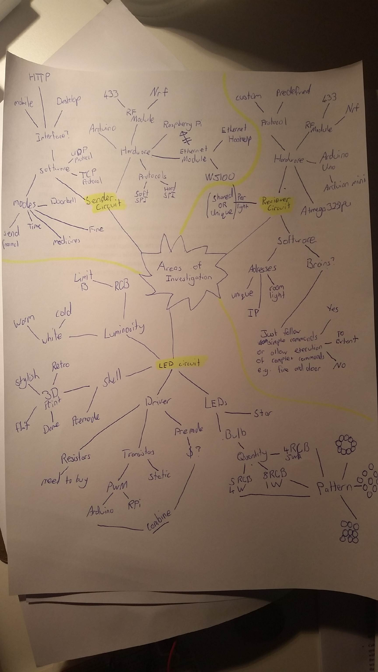

This mind-map greatly helped me put my ideas on paper, so I decided to make another one for the communication methods to be used in the system.

I decided to use a mind-map and flowchart hybrid to plan out how I was going to achieve the system communications as a whole. Through my testing of many different components, I have concluded that the end product will consist of a phone connecting via Wi-Fi to a wireless router, which will then send the data collected from the phone through an Ethernet cable to the RPi. The RPi will then process this data and then send that to the Arduino Uno using Serial connection. The Arduino Uno will then transmit this data using an RF module. The receiving Arduino Uno will pick up this data with its RF receiver. This Arduino will process the data then output the information through PWM to the light circuit.

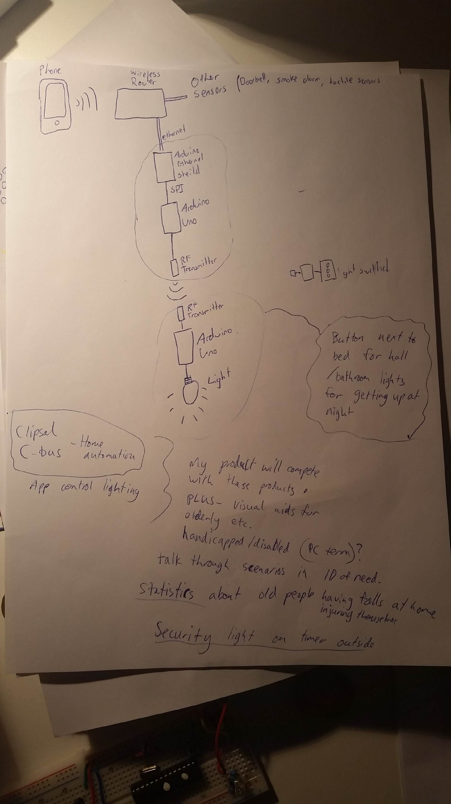

### Inner Workings

#### Software of Raspberry Pi

The software on the Raspberry Pi serves three different purposed, to get user input, to process the input, and output that in the communication protocol that the infrastructure can understand. Here is the list of the order of events that occur:

1. The Raspberry Pi (RPi) initialises a local server on the network
2. The RPi then waits for a HTTP request to be made
3. The RPi reads the users input and cuts out the bits it does not need
4. The RPi then reads the first 4 characters of the data it has. These 4 characters will spell out the type of function that the user is planning on using. An example of this can be ‘fire’ or ‘door’.
5. The RPi then runs the corresponding function to what the user has asked for
6. The next 3 characters are read. These three characters are the address destination. The first character defines the room of the destination address, the second is for data accuracy, and the third is for the light address in that specific room. I will get into the specifics of the protocol <> after this.
7. The next 16 character are read, these are the data characters. The RPi will process these characters differently depending on the function that it is set to perform.
8. The next 2 characters are read. These characters are part of an error checking process to make sure the data is accurate.
9. After all characters have been read and processed, it is now time for the RPi to repack the data into respective format to be sent to the Arduino via Serial communication.

The protocol used for the sending of data through the network is of my own creation. Through my completion of the Information, Processes and Technology Board of Studies course I completed in 2013 I had adequate knowledge to do so. The protocol I made consists of 4 parts, the function type, the destination address, the data to process, and an error checking method similar to a checksum. An example data package sent with my protocol may look something like “send3.620000010000012”, to break down this data into information, here is what it does: Send the following information to the 6th light in the 3rd room, Red: 200, Green: 000, Blue: 100, White: 000 and check that it is correct with the error checking code of 12. This would result in the addressed light in lighting up into a purple colour. The error checking method is done by summing up all the characters in the data packet (excluding the last two characters, which are the error checkers) in their ASCII numerical values. After these values are added together, the number can for example 1539. When the number is over a 99 (a two digit number) the digits are then added together, like so: 1 + 5 + 3 + 9, which equals 18. 18 is now our error checking number that will be added to the end of the data packet.

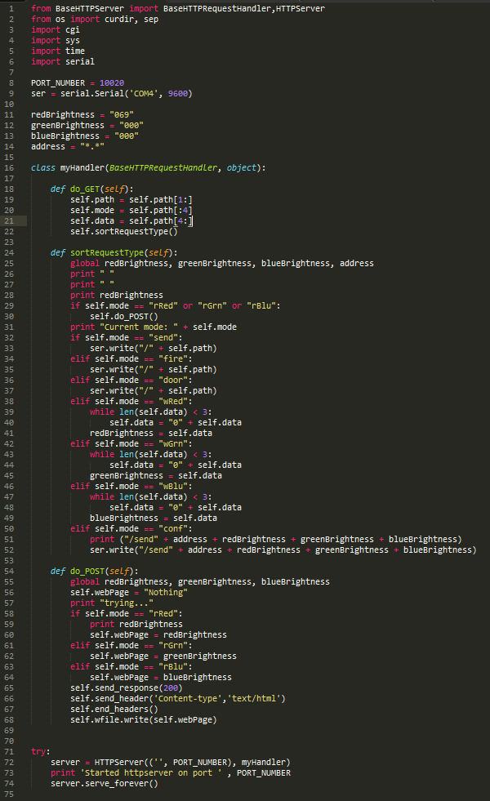

#### Software of Arduino Sender

The software on the Arduino Sender serves four different purposes, to read the RPi Serial input, to read button input, to process the input, and output that in the communication protocol that the infrastructure can understand using radio frequency. Here is the list of the order of events that occur:

1. Forever wait until the RPi attempts to send something
2. Once the RPi sends data through Serial, read what it says byte by byte.
3. Optional error checking could be done here, but the chance of an error produced by the communication of Serial is almost 1 in a million, so it would not be worth checking as the error will be picked up later in the data’s journey <>.
4. Barely any processing is done to the data packets on the Arduino Sender. The only thing that is added is an End Char at the end of the transmission to signal the end of transmission. This is a special invisible char that has an ASCII value of 2.
5. The Arduino Sender goes through byte by byte and displays that onto radio frequency waves.

The sent data packet is almost identical to the one the RPi passes to the Arduino sender, albeit the end character that consists of the special End Char character.

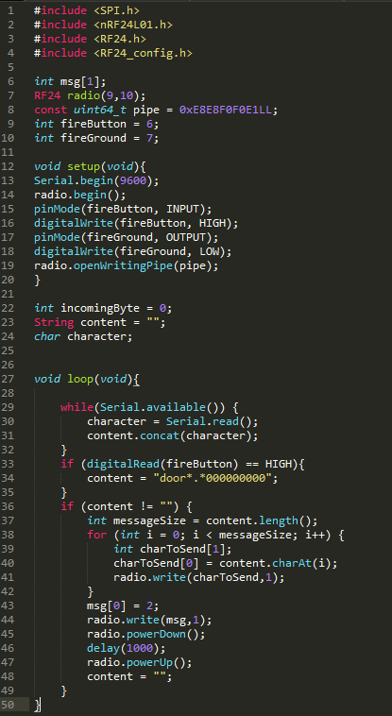

#### Software of Arduino Receiver

The software on the Arduino Receiver serves three different purposes, to read the Radio Frequency input, to process the input, and output that in Pulse-width modulation (controls the width of the pulse, formally the pulse duration allowing a varying voltage to be used. This varying voltage then allows the control of each LEDs brightness). Here is the list of the order of events that occur:

1. The Arduino waits forever until there is activity of radio frequency
2. The arudino reads the data sent through radio frequency
3. The Arduino then processes this data and splits it into different bits, address, mode, data, and checksum
4. The checksum is then used against the data packet to validate it is correct
5. The Arduino then reads the address, and if it is its own addresses continues, if not the Arduino goes back to step 1
6. The mode is then checked and if it is either door, or fire modes they are executed specially. If it is a normal light adjustment the data is read and the different colours are lit up according to the data



### Functions

#### Standard RGB Function

The standard

#### Fire Alarm Function

#### Door Bell Function

#### Timer Function

### Circuit Creation

#### Creation of Arduino Receiver Circuit

##### Receiving Circuit

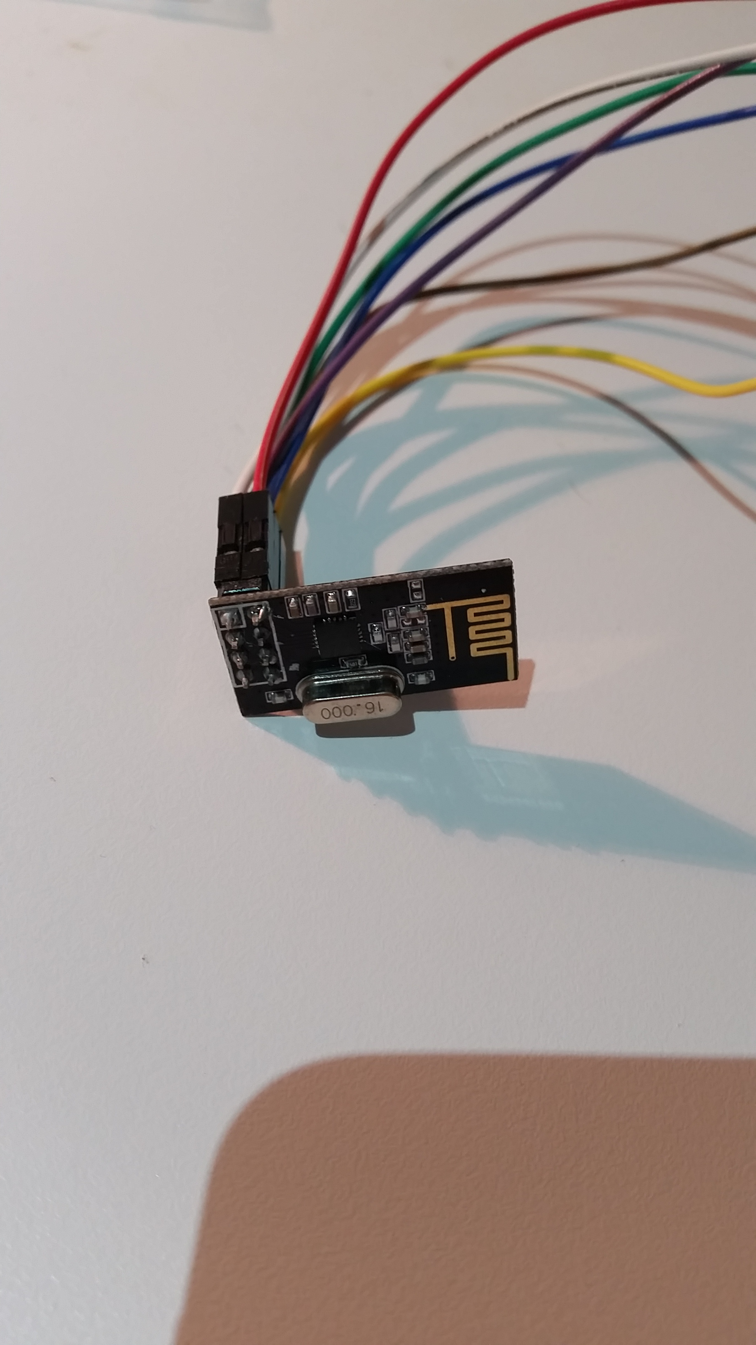

##### Processing Circuit

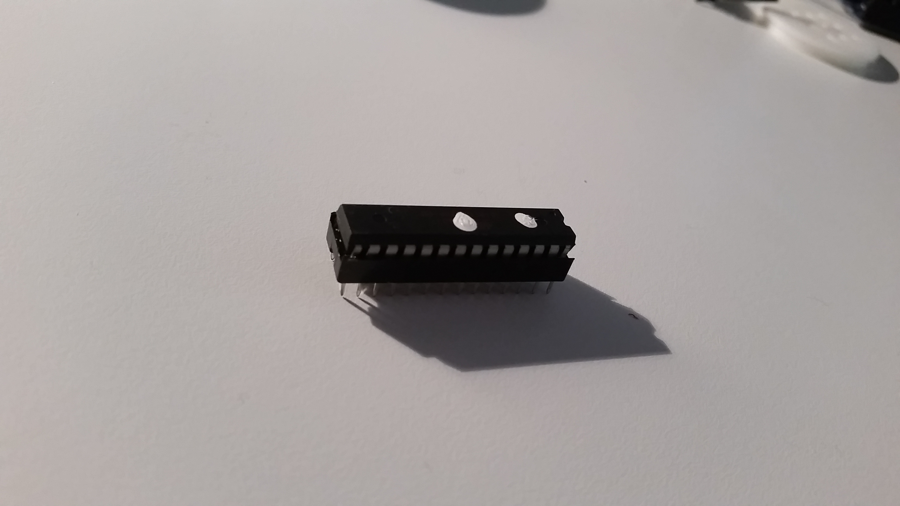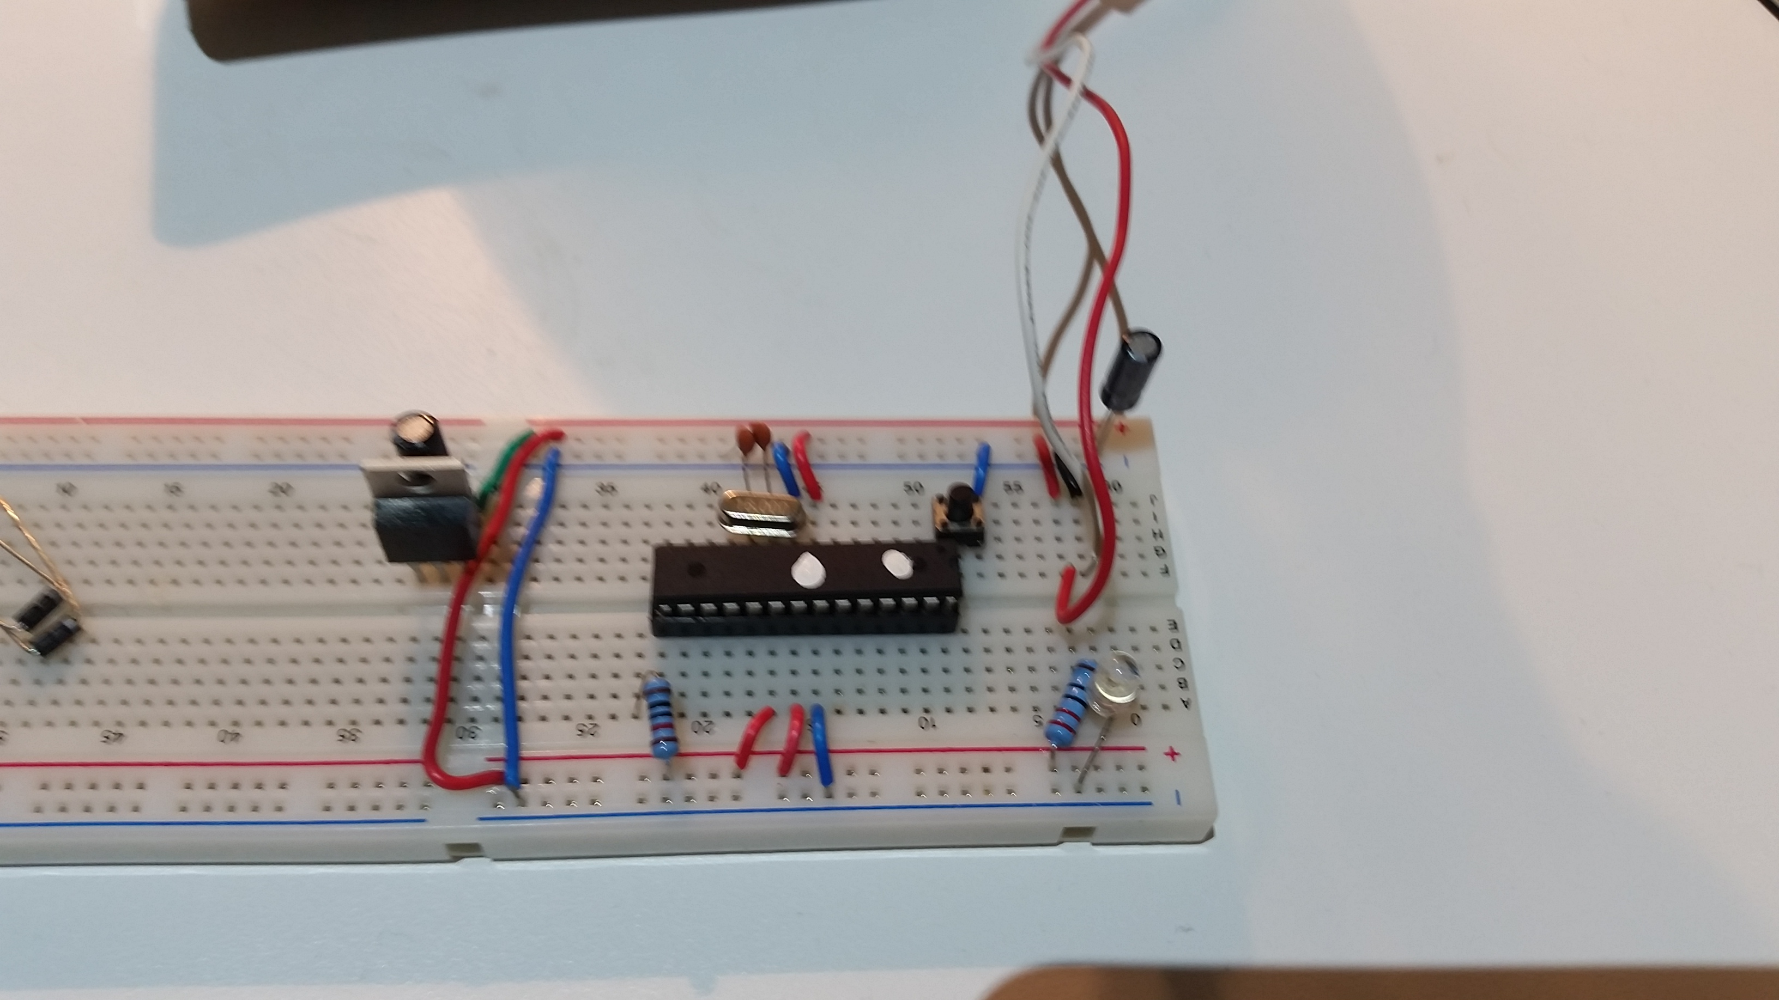

##### Output Circuit

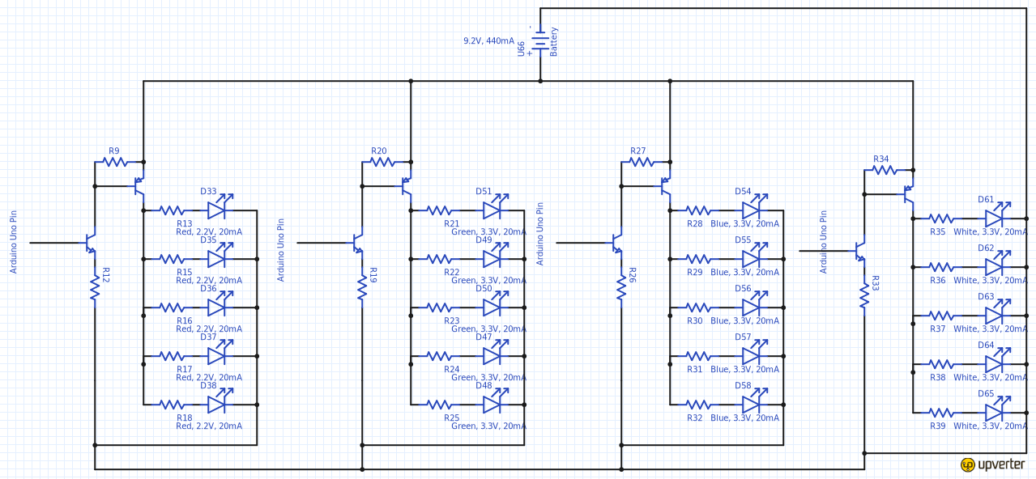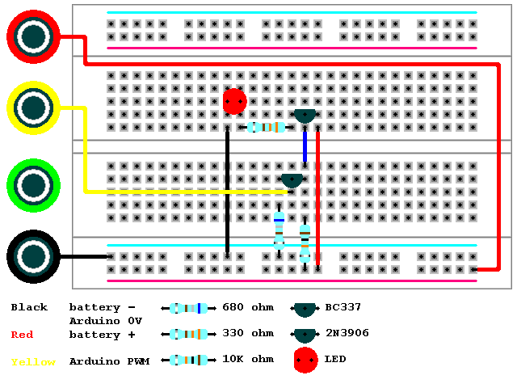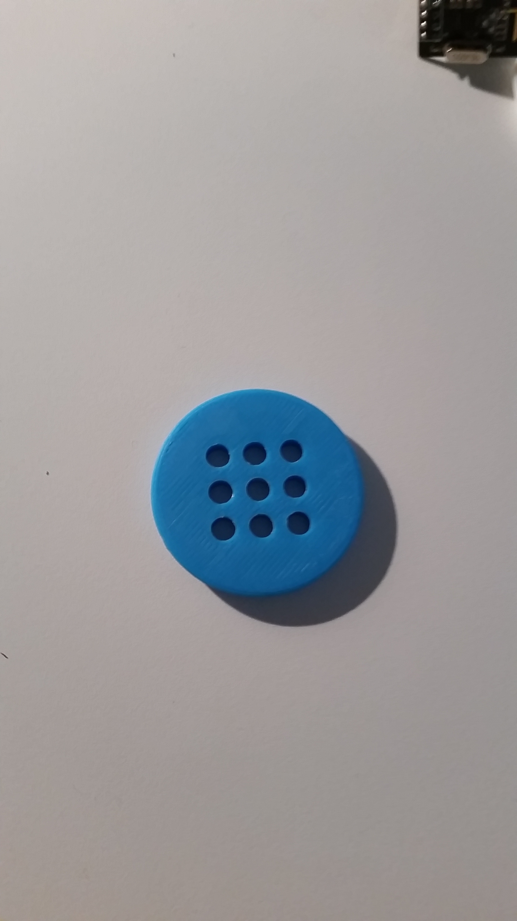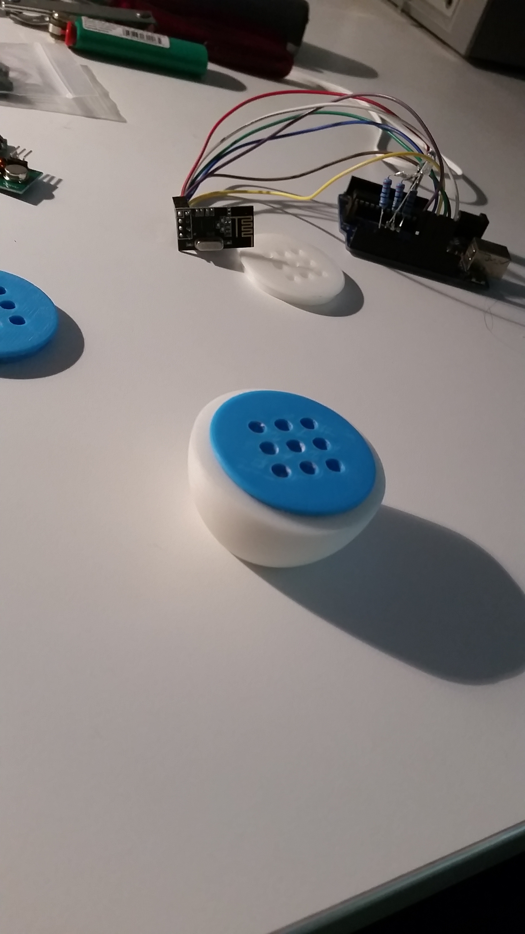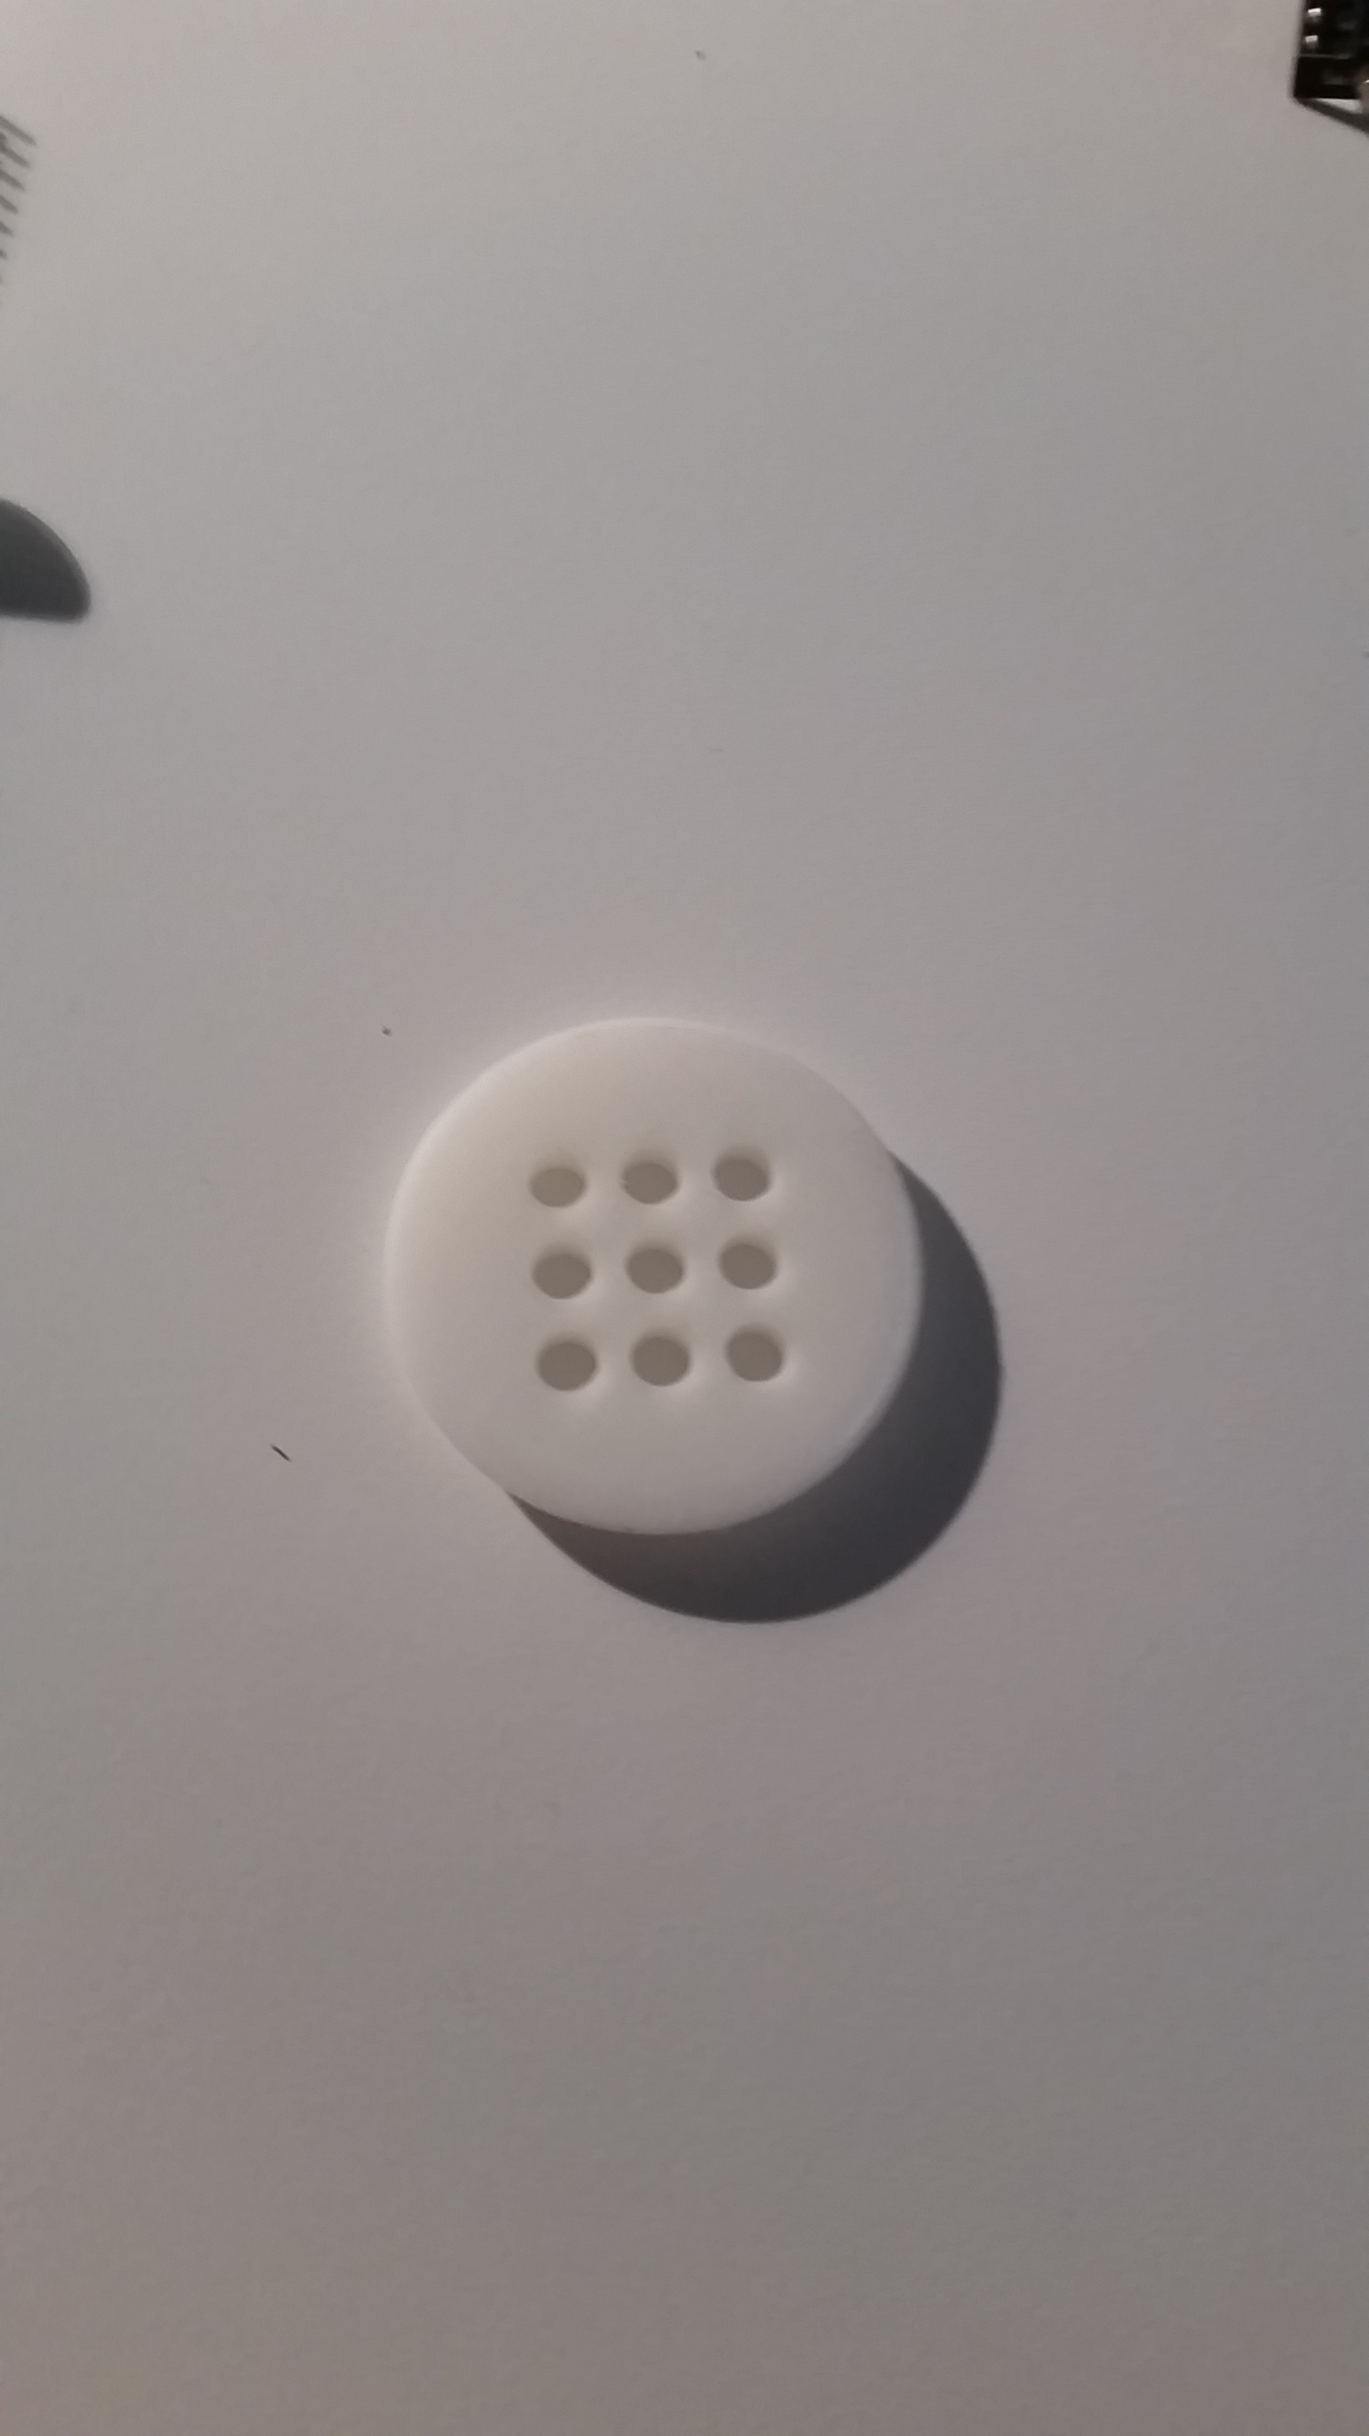

## Exploration of Existing Ideas and Degree of Difference

After finding this is existing idea which could act as a framework I decided to email to developer to see if it was possible to add a feature:

Me:  
“Hi there,   
I am currently creating a major project for my last year of school. Your app is what I am using for communication, but I was just wondering when the RGB colour picker will be released for the NetIO app, as it will make my project much more better. Is there any chance I could get a beta version of it, if it's already in development? (Android)

If so, thank you! If not I understand.

Regards,   
25313399”

Developer:

“Hi *25313399*,

Thanks for your mail. I saw you are already working on three sliders to set the colour! The colour-picker is the next item we are going to implement. However, my brother who is developing the android app is on holidays for a few weeks now as he graduated a couple of days ago ;)

We can invite you to beta testing, however the colour-picker will come in September or October... (But not guaranteed!)

I suggest using sliders (and make them coloured in red/green/blue) as I did in my living room (see attachment)

Best regards

David”

Me:

“Hi David,

Thanks for your fast reply! I am using the sliders but they are not quite working as I expected and they can be a bit buggy.

Are there any other solutions to this problem that you would suggest?  
  
Also, for my project that we talked about earlier, is there any chance you could give it a quick review and evaluation? It would help me majorly! I have attached relevant documents.

Regards, 25313399”

Developer:

“Hi again 25313399,

I would suggest maybe using 3 different buttons instead for each colour, one for off, another for half brightness and another for full brightness. This is an easier solution, but still with great functionality.

I would love to review your project! (So long as you share it on the NetIO forums!)

I very much like the design of the communication you have used from RPi to Arduino then RF to another Arduino. I might suggest though that you do not send too much data through these too fast, as the NetIO app might freeze up, and so will the receiving Arduino.

You also might want to look at using Common Anode RGB LEDs instead of Common Cathode next time to save on component use.

Please keep me updated on this project, as it looks very interesting!

Best regards

David”

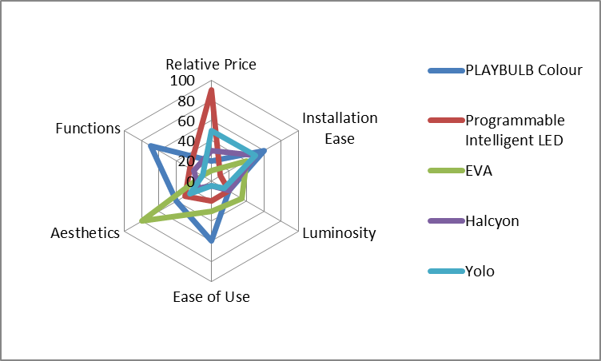

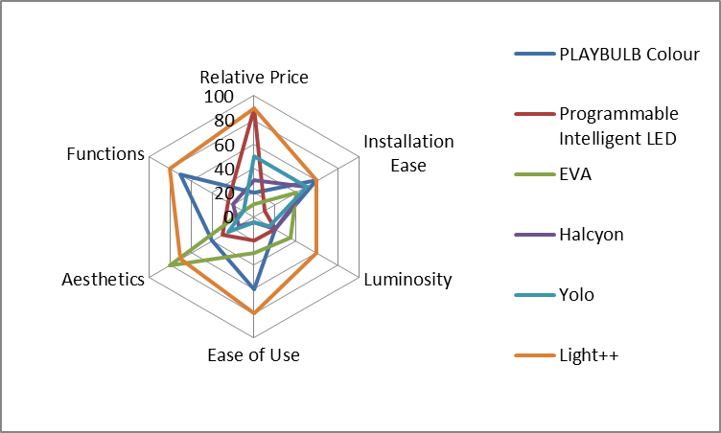

## Consideration of Design Factors Relevant to the Major Design

|  |  |  |
| --- | --- | --- |
| Factors Affecting Design |  |  |
| Factor | Description | How I have applied this factor |
| Function |  |  |
| Size Light |  |  |
| Luminosity of Light |  |  |
| Distance for Wireless Communication |  |  |
|  |  |  |
|  |  |  |

## Appropriate Research and Experimentation of Materials, Tools,

### Industrial vs School Based Production

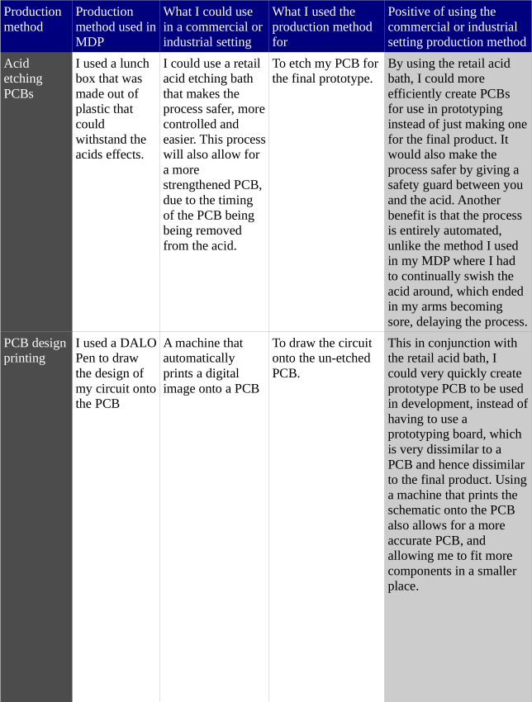

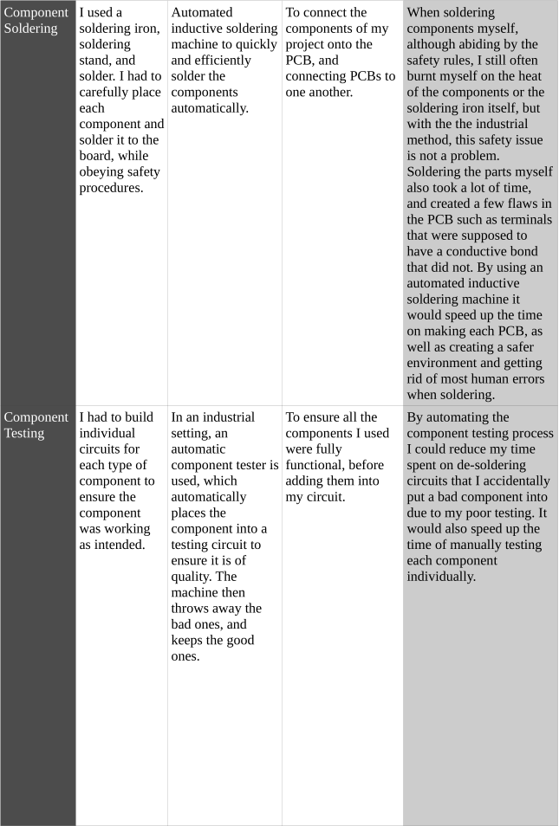

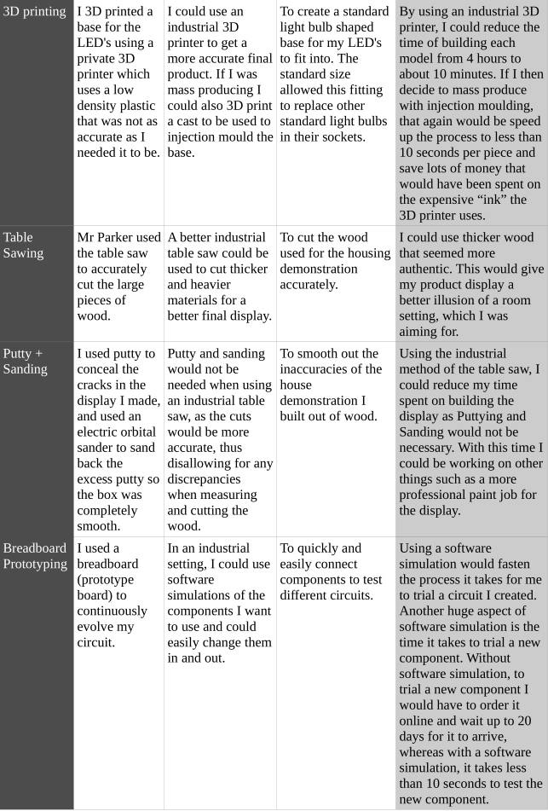

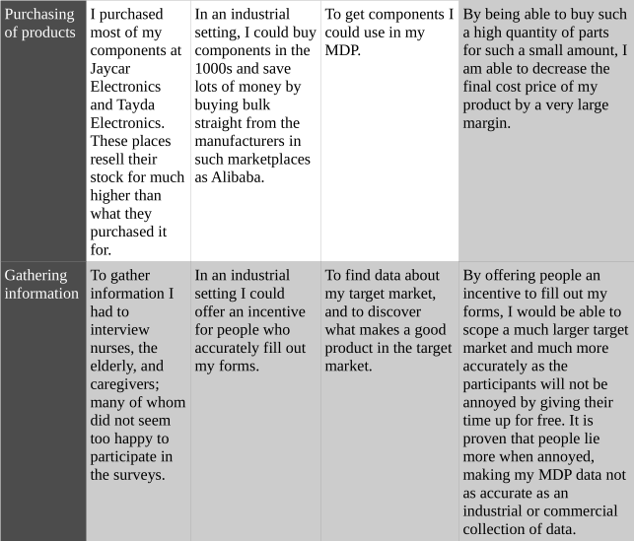

## Techniques and Testing of Design Solutions

### How I made the PCBs

I am making my own circuit boards for the project, so I need to know how to make them, and practice doing this. PCB is a component made out of layers of insulating materials with electrical conductors. The insulator can be made of many materials, mainly plastic, fibreglass and ceramics. During manufacture, the extra conductors that are not required, are etched off leaving a printed circuit where I can attach my electronic components.

Safety

* I am going to be using very corrosive chemicals and eye protection must be worn.
* If any acid gets on my skin/clothes rinse under water immediately.
* If any acid ends up in my eyes rinse under water immediately and seek medical help.
* A blow torch can get very hot and should not be handled by a student, so my teacher offered to do it for me.

What materials/equipment are needed?

* Copper Clad Board
* Waterproof Permanent Marker
* Etching Acid (Ferric Chloride or Ammonia Persulphate)
* Drill
* Tinsnips
* Hacksaw
* Steel Wool
* Bath for etching
* Multimeter
* Blow Torch

Procedure:

I started with a rough design of what I wanted the PCB to look like. Note, this PCB was a test and does not reflect the final PCB.



I then used an Airline marker pen to careful draw the schematic on a piece of copper PCB.

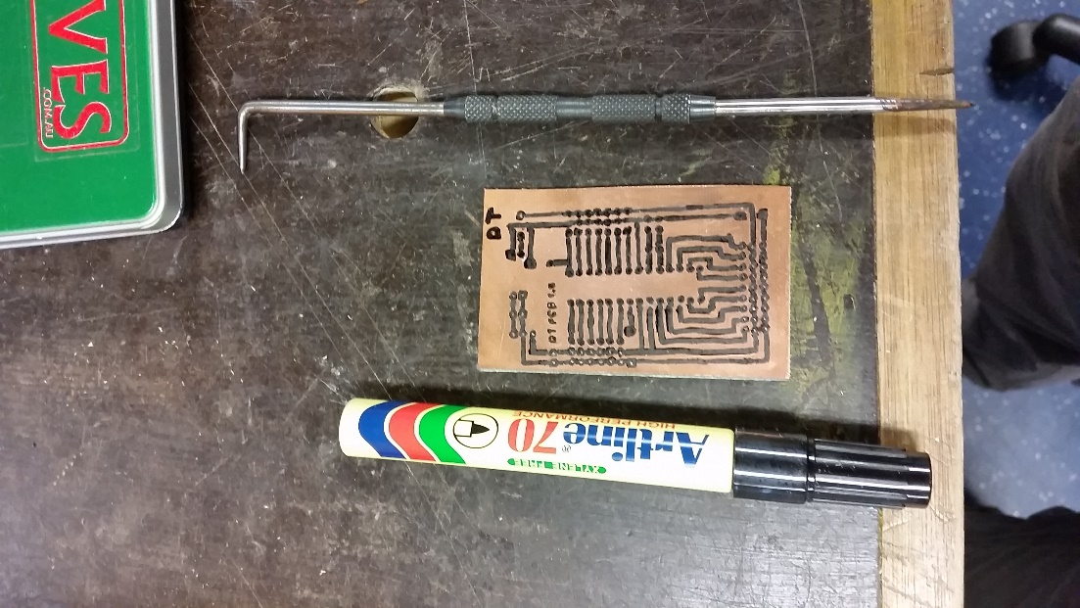

I let the ink dry and made a solution of hot Ferric Chloride (acid) to dissolve the copper, but leaving the marker pen where it was, and protecting the copper underneath it.

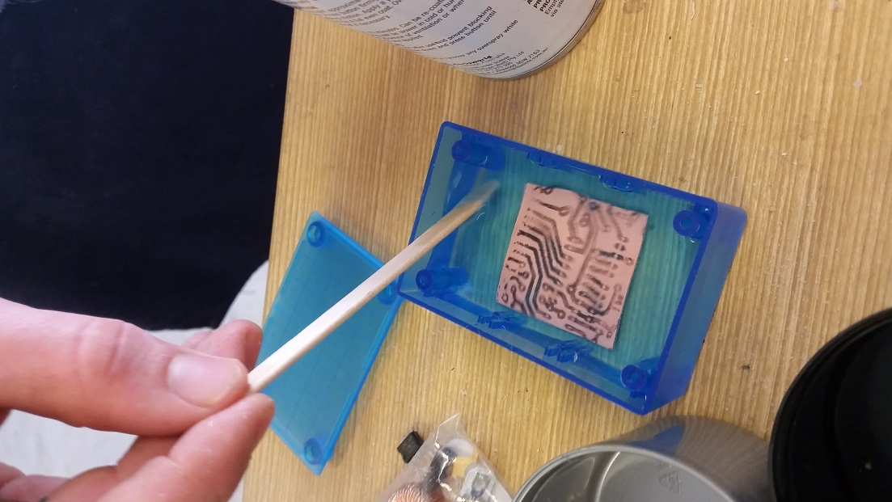

After 15 minutes, the copper had fully dissolved where it was exposed to the acidic solution. What remained was a piece of clear PCB with market on it. I used steel wool to scratch the marker off, leaving the copper where it was.



I drilled out where I had marked the white and red circles, this will be where I put the components. The final product looked like this:

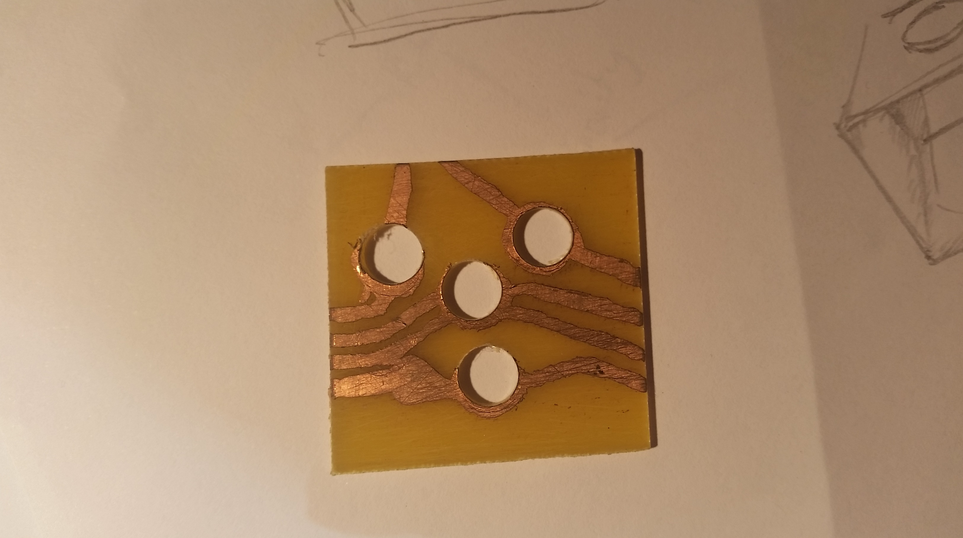

The PCB turned out to be a success in some aspects, but a complete failure in others. Through this testing of the PCB method, we discovered that we would need a much more accurate way of drawing our schematic onto the plain PCB. My school teacher came up with a good idea, and that was to print the schematic out using an ink printer, compress the printout to a piece of copper PCB and heat using fire until the ink melted onto the PCB.

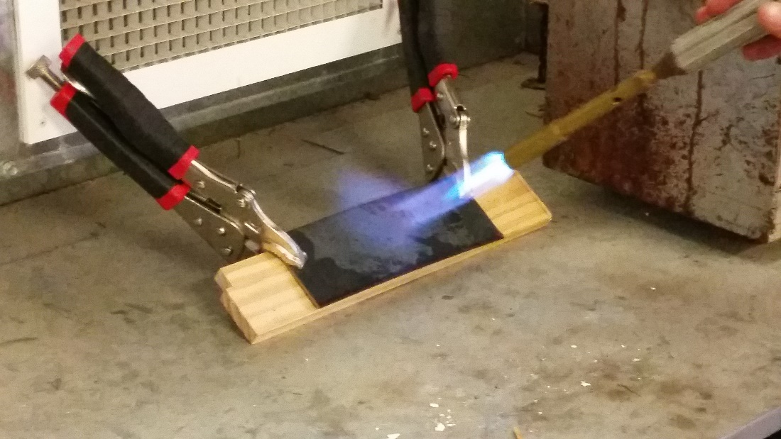

After removing the PCB (and paper) from the compressed contraption, we were left with a PCB board that looked like a complete failure.

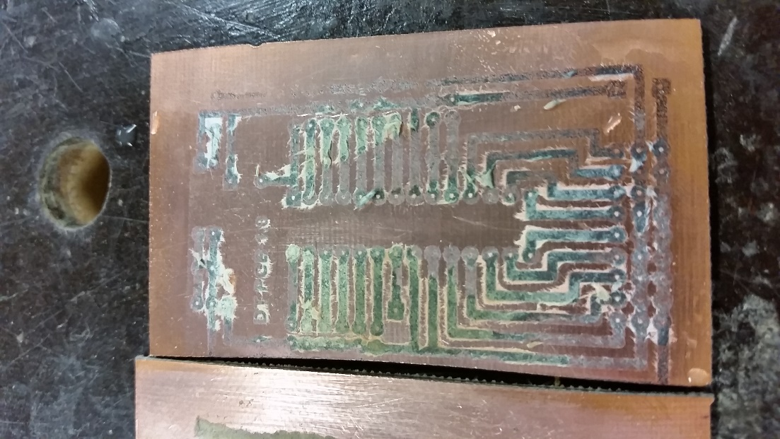

We decided to make three more, just to test that we had not failed making the PCB, and they all turned out similar. We were quite annoyed, but decided to put them in acid anyway to dissolve. After about 10 minutes in the acid, we discovered that we may have actually done the procedure correctly.

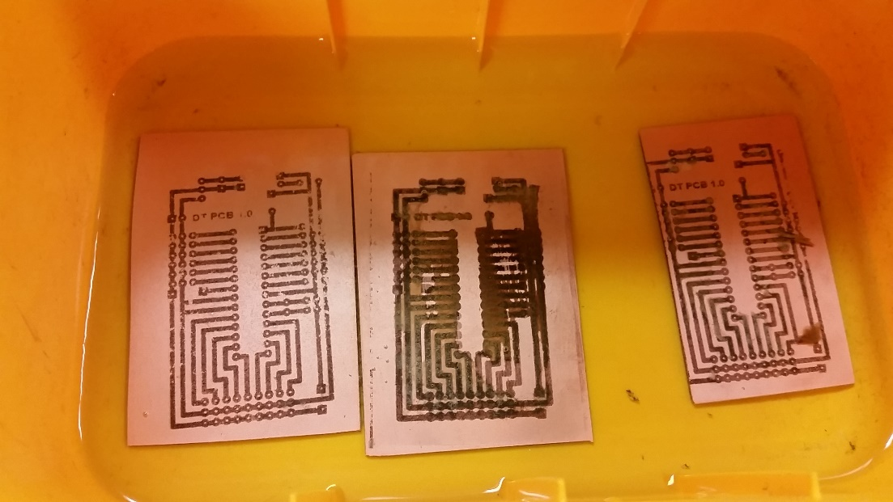

With the board on the left looking pretty much perfect. After 10 more minutes the exposed copper finally dissolved and left us with three completely different looking PCBs

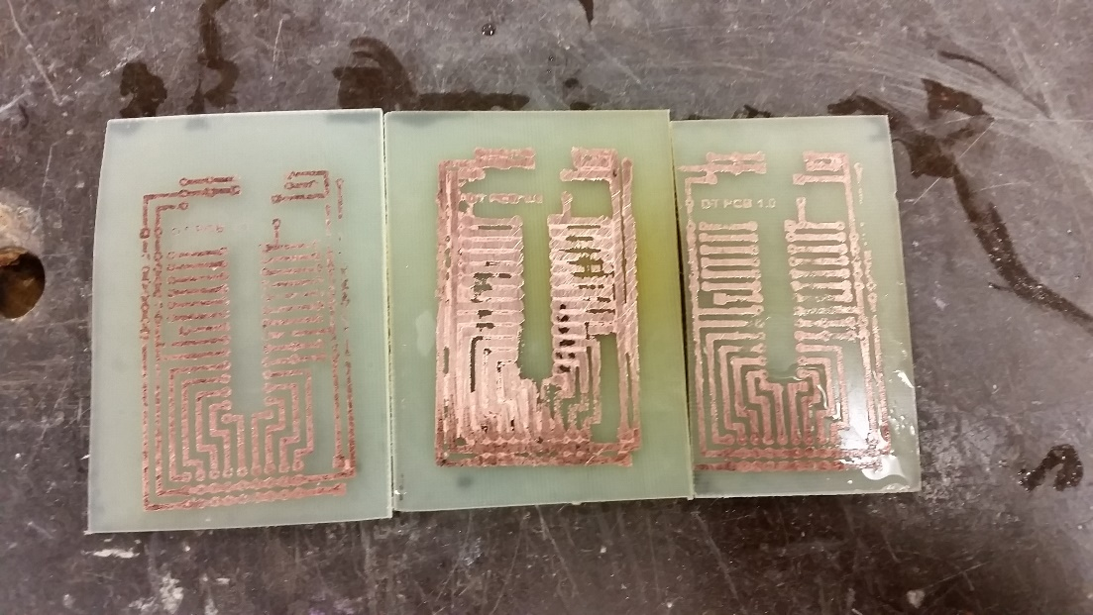

The left one turned out the best, but had a few issues in the top right hand corner due to what I expect to be heating issues. The one in middle must have gotten heated too much and resulted in a failure of a PCB where all the different lines were connected. The one on far right was perfect though, and we decided to use it to continue testing my circuit. Here is a close-up of the far left PCB:

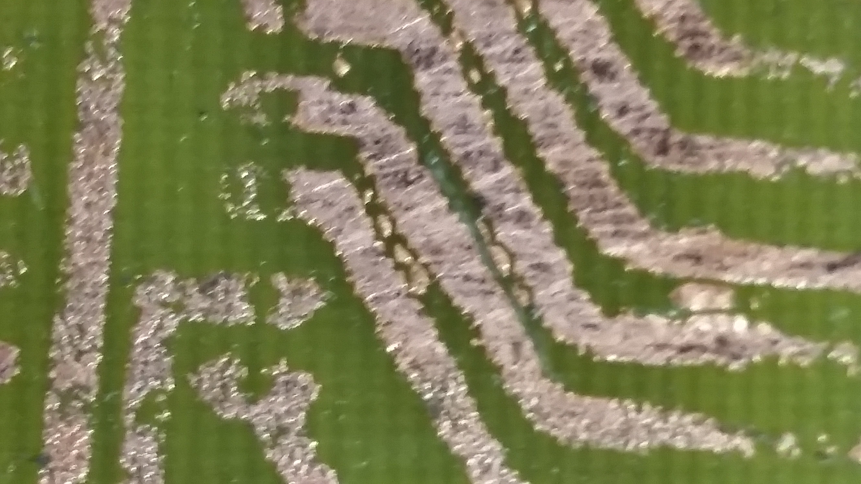

## Product Display

To properly display my product, I decided to built a display for it.

|  |  |
| --- | --- |
| Aspect | Why is this aspect needed? |
| Enclosed | The display will need to be enclosed as to allow it to be dark. I want it dark so the light looks more bright and colourful. |
| White | The display needs to be white so that each colour can appear as it is without being changed. For instance, if the display was blue, the red light would look purple. |
| Mimicks a room | I want this display to feel like it is a room, this will allow the person who is looking at it to properly grasp how it would like in a proper sized room. |
| Large in volume | I want the room to be large in volume so the colours and brightness are spread out evenly and not just concentrated on the one spot. The light would be concentrated on one spot if a surface was 10cm or closer to the LEDs. |
| Clear top | I need the top to be clear to properly demonstrate the circuitry that is driving these lights. |
| Lightweight | I want this display to be lightweight so it can be easily carried around, especially from my house to school and back. |
| Clean | The room must look clean. If the room does not look clean it will reflect poorly on my product, making it seem as if I did not care about it. |

I started off by drawing a 3D view and a cut section view of the box. This helped me to understand what I might expect.

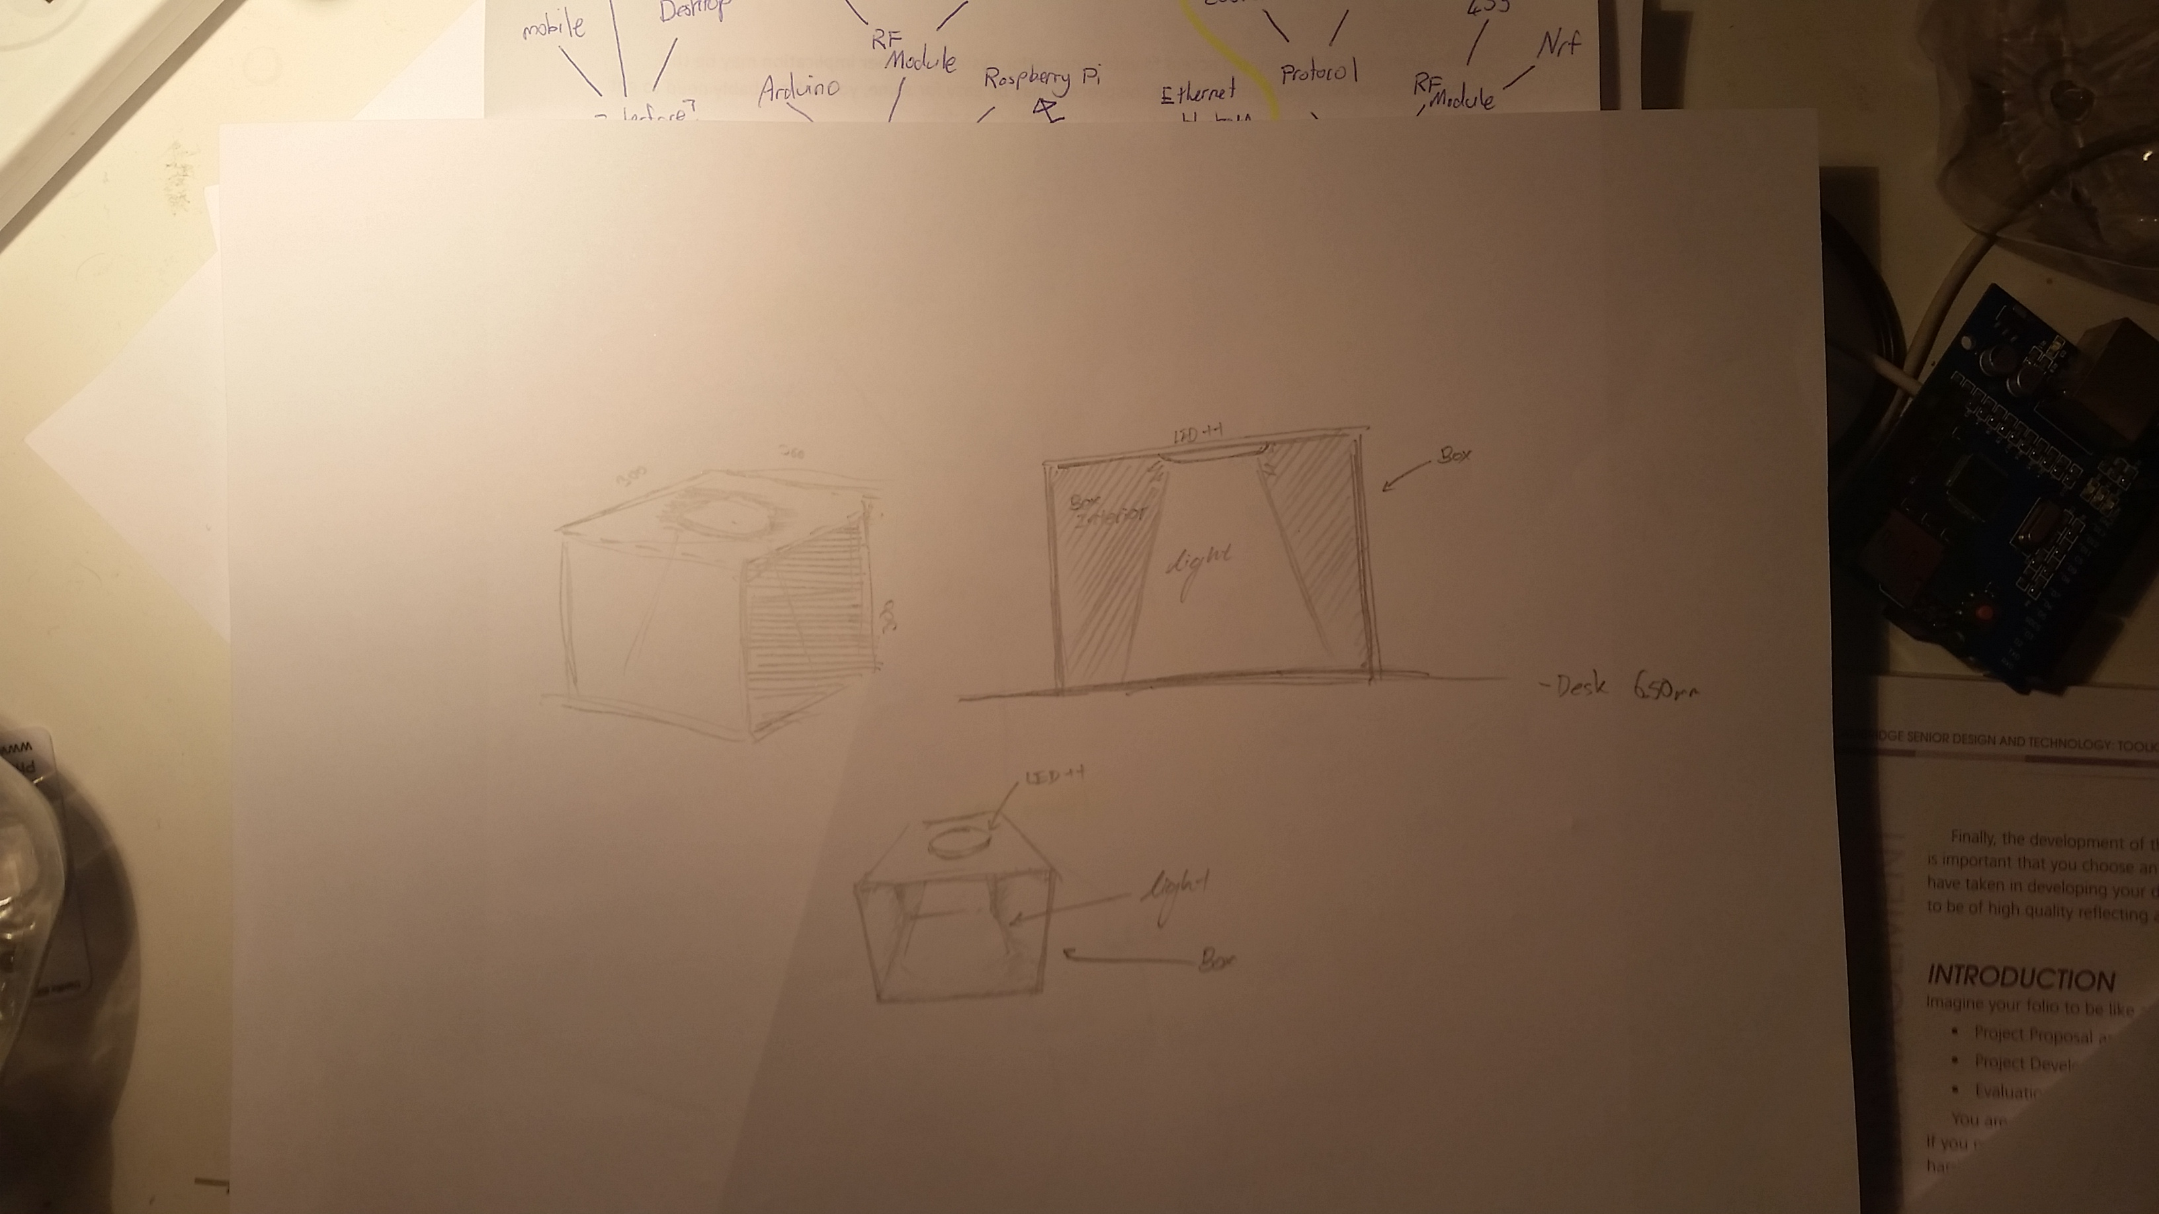

Next I asked my Design and Technology teacher to help me design what this box should technically look like from the isometric view, side view, and top view.

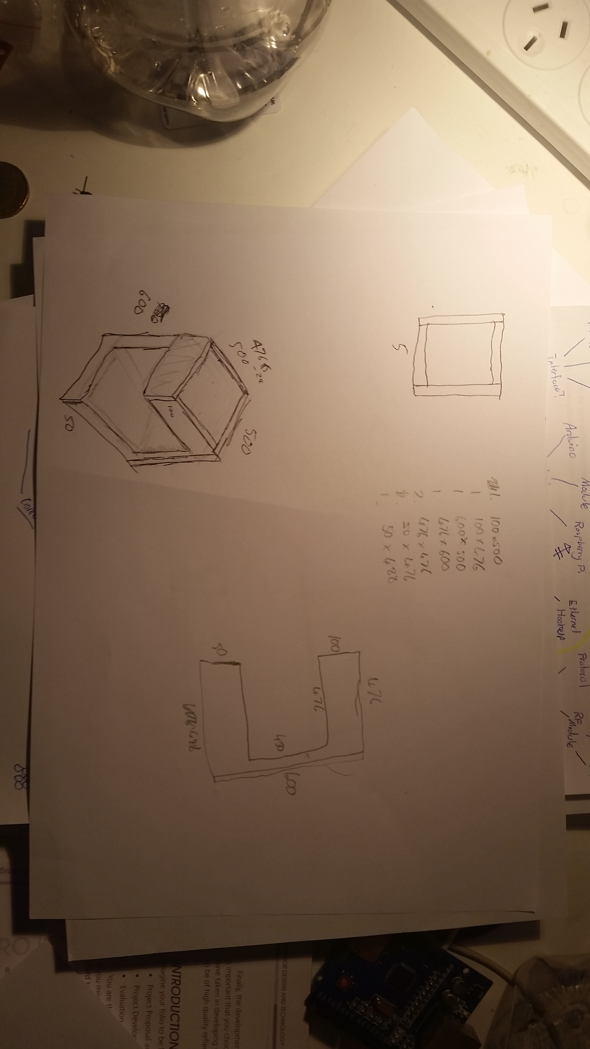

After I was happy with how it looked, I planned out the size I wanted the box to be. I chose a very large size as to meet my previous criteria. After, I planned out the shapes and sizes of the pieces of wood I needed to use in the product. There was a few pieces, so we decided to use the bandsaw to cut the wood. Safety and caution were a priority so my Design and Technology teacher cut the wood for me, while we both wore ear and eye protection. The wood was chosen based on its weight and smoothness, this links back to my criteria in the lightweight and clean aspects. We decided to go for MDF wood as it perfectly matched this criteria. After cutting the wood, I assembled the pieces using PVA glue. Unfortunately on evaluation I realised that there were a view cracks in the joins of the wood, and some bits were not level. I fixed this problem by using putty to patch up the holes, then sanding it away. In the end I ended up with a completed box.

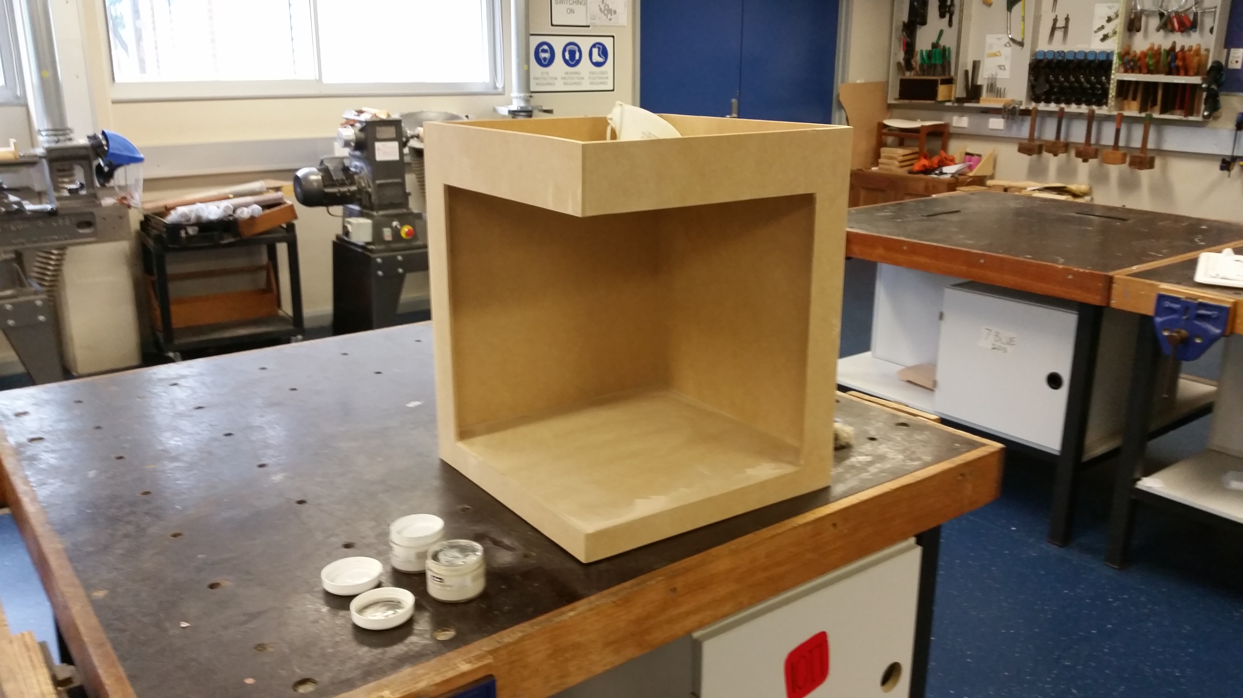

To make this completed box into my completed display, I needed to paint it white. The school had some white paint I could use. I painted each side twice for a nice clean final product.

# Project evaluation

## Criteria for evaluation

## Analysis of evaluation

## Impact of the major design project on the individual, society and the environment.

Throughout the project I have kept a record of what I have been doing and how I have followed my action plan to keep on track. I have also made evaluations throughout the project recording decisions made and reasons for doing so. These should be evident when looking through the folio.

### Record of Progress - Diary

How project developed to completion Comments

2011, Term 4

|  |  |
| --- | --- |
| How project developed to completion | Comments and Evaluation |
| 2013, Term 4 |  |
| * Looked into what project to do for my MDP through mind mapping of the current needs of the market and finding potential niches | Term 4 I did not complete as much of my project as I should have. I wanted to take this time to ensure I am making something that I would like to continually design for the next 3 terms. |
| 2014, Term 1 Week 1 |  |
| * I continues my research to explore the gaps in the market and stumbled upon my grandmothers need for a visual alert system |  |
| Week 2 |  |
| * I began my research of existing products and whether it was possible to fulfil my grandmother’s need. |  |
| Week 3 |  |
| * After finding out that I could in fact make this product, I also discovered that I could include many more features and decided to interview people from the target market |  |
| Week 4 |  |
| * I was sick this week and did not complete much work |  |
| Week 5 |  |
| * I attempted to make up for last week by doing lots of MDP work. I researched which resources to use for my project and completed a long evaluation of all previous task completed |  |
| Week 6 |  |
| * Sick |  |
| Week 7 |  |
| * Sick |  |
| Week 8 |  |
| * Sick |  |
| Week 9 |  |
| * I was now a little behind in what I wanted to complete by this stage, so I decided that I would build a prototype to attempt to see just how this product would turn out. |  |
| Week 10 |  |
| * I was still completing the prototype. On Friday it was 70% complete, but I am not planning on working on it on the weekends. |  |
| Term 2 Week 1 |  |
| * After the holidays I had a positive outlook on this prototype and decided to put more effort into it. By this stage it was 80% done, but the scope of it is far greater than my vision for it in week 10 of term 1. |  |
|  |  |
|  |  |
|  |  |
|  |  |
|  |  |
|  |  |
|  |  |
|  |  |
|  |  |
|  |  |
|  |  |
|  |  |
|  |  |
|  |  |
|  |  |
|  |  |
|  |  |
|  |  |
|  |  |

Analysis and Evaluation of Aesthetic and Functional Aspects of my Design

This design project is primarily used for its function and so these features are most important, however aesthetics is also considered.

|  |  |
| --- | --- |
| Functional Aspects | |
| Is it a quality product? |  |
| Is it safe? |  |
| Does it work as expected and intended? |  |
| Is it long lasting and durable? |  |
| Is it made from appropraiet materials |  |
| Has the target market been considered? |  |
| Is it easy to use? Are there any instructions needed  for appropriate and safe use? |  |
| Aesthetic Aspects | |
| Is it an attractive design? |  |
| Is it likely to appeal to the target market? |  |
| How could I improve the look of this design? |  |